
Survey among Local Christians

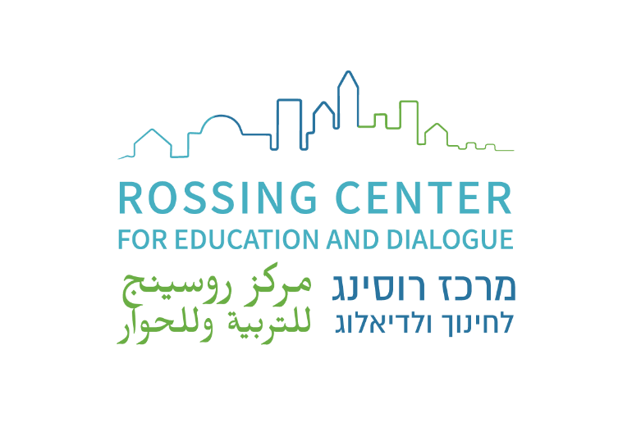

in Israel and

East Jerusalem

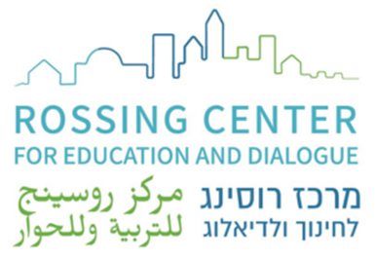


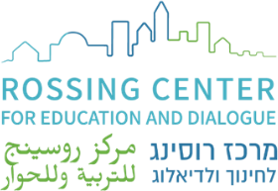
Survey among Local Christians in Israel and East Jerusalem

About the Rossing Center:

The Rossing Center for Education and Dialogue is an interreligious organization based in Jerusalem that promotes a shared society founded on peace, justice, and equality for all religious, ethnic, and national groups. Through education, encounter, research, and consulting, the Rossing Center fosters improved relations between Jews, Christians, and Muslims, as well as between Israelis and Palestinians in the Holy Land. Established in 2004, the Center addresses the complexities of interreligious, multicultural, and bi-national communities, encouraging its beneficiaries to drive change in knowledge, perception, and behavior through diverse educational and dialogical initiatives.

Preface:
The Rossing Center for Education and Dialogue conducted this survey to gain a deeper understanding of the challenges, needs, and aspirations of Christians in Israel and East Jerusalem—specifically Arab-Palestinian Christians, who form the majority of these indigenous communities and are either Arab-Palestinian citizens of Israel or East Jerusalem residents. Building on our longstanding work in Jewish-Christian relations, and particularly our recent two-year advocacy efforts aimed at enhancing the safety and well-being of Christian communities, it became clear that a direct consultation with community members themselves was necessary. This survey represents a deliberate move to engage directly with these communities in order to inform and refine future initiatives, but also to provide the Churches, researchers, and the wider public with updated information. The urgency of such research has grown in response to ongoing political changes pointing to a more polarized context, which is less tolerant of diversity, and the wider uncertainty surrounding the future of the Middle East. Findings from multiple studies consistently point to several growing concerns among Arab-Palestinian Christians, including identity struggles, experiences of inequality, a complex relationship with the state, and a pressing need to strengthen ties with local churches.
Between 130,000 and 140,000 Arab-Palestinian Christians live in Israel and East Jerusalem, comprising approximately 6.9% of the total Arab-Palestinian population in the country.

Although relatively small in number, they represent a significant minority—not only due to their centuries-old presence in the region, but also because of their prominent social and symbolic roles. Arab Christians play a vital role in shaping Israeli-Palestinian relations, hold considerable importance for global Christian communities given the Holy Land’s religious significance, and influence Jewish-Christian relations in both theological and political spheres.
As Christians and Arab-Palestinians, they constitute a double minority: nationally, they are part of the Arab-Palestinian population; religiously, they are a minority within that group. In recent decades, this identity has become even more complex. In light of these developments, we felt it was critical to examine how local Christians are navigating urgent dilemmas related to personal safety, identity, political representation, and marginalization. This report seeks to understand their perspectives on these evolving challenges and to explore how Christian institutions can respond to their changing needs.

Terminology:
Local Christians: This term refers to the 130,000–140,000 Arab-Palestinian Christians residing in Israel and East Jerusalem. The survey does not include Christians who immigrated from the former Soviet Union or are of Russian descent, foreign clergy, or migrant workers.
Mixed cities: In the Israeli context, "mixed cities" refer to urban areas such as Haifa, Acre or Lydda and Ramle, where significant populations of both Jewish and Arab-Palestinian residents live in close geographic proximity. These cities are characterized by ethnic, religious, linguistic, and cultural diversity, and often reflect the broader complexities of Jewish-Arab relations within the state.
Arab-Palestinian Citizens of Israel: This term refers to ethnic Arab-Palestinians who hold Israeli citizenship. They make up about 17% of Israel’s population (about 1.5 million people).
Palestinian Residents of East Jerusalem Palestinian individuals who live in the eastern part of the city of Jerusalem that was occupied and annexed to Israel in 1967. They hold permanent residency status in Israel, granting them social and economic rights but not full citizenship.
Nation State Law: A Basic Law passed by the Israeli Knesset in 2018 that defines Israel as the nation-state of the Jewish people. It excludes non-Jews from having the right to self- determination in the State of Israel, affirms the Jewish identity of the state, constitutes Hebrew as the official language (with Arabic given a special status), and promotes Jewish settlements as a national value.

Holy Land: The term refers to a region of historical and religious significance that holds sacred importance to the three major Abrahamic religions: Judaism, Christianity, and Islam. Most commonly, the term refers to areas that include modern-day Israel, and the Palestinian territories (including the West Bank and Gaza Strip).

Background statistics:

The survey revealed distinct regional differences among respondents, highlighting the influence of geography on their perspectives. Most of the Arab-Palestinian Christians reside in the Northern District (68.2%) and in the Haifa District (14.6%). The localities with the largest Arab-Palestinian Christian populations are Nazareth (19,800), Haifa (18,700), Jerusalem (13,000), and Shefar'am (10,600). Geographically, most Arab-Palestinian Christians are concentrated in four main areas:
- East Jerusalem, where approximately 40% of the population is Palestinian, and among them, about 1.3% of the total population are Christians. East Jerusalem presents a particularly complex reality. Residents there are not Israeli citizens and generally receive fewer public services compared to those in West Jerusalem. Despite the close proximity to predominantly Jewish West Jerusalem and the existence of shared public spaces, tensions between national groups are heightened, largely due to the area's deep religious and national significance.

- The Central Region, mainly the mixed cities of Lod, Ramle, and Jaffa, where Arab- Palestinian Christians constitute approximately 1.2%, 4.5%, and 5% of the population, respectively. These cities are characterized by a more integrated urban environment, where Arabs and Jews live, though Christians often represent a small minority.

- Haifa, where approximately 12% of the population is Arab, and about half of them are Christians. Haifa is a mixed city, although Arab Christians still form a demographic minority.

- The Galilee, where Arab-Palestinian Christians primarily live in Arab towns and villages. In this region, there is generally less day-to-day interaction with the broader Jewish Israeli population, as communities tend to be more homogenous and geographically separated.

Executive Summary:

The survey was organized according to four main clusters of interest:
- Attitudes with regard to Israeli society.
- Attitudes with regard to the State and its authorities.
- Attitudes with regard to the Christian religious institutions and their communities.
- Assessment of future perspectives: emigration, fears about the future in terms of status, freedom of expression etc.
- Definitions of Identity
The geographical distribution of Christians in Israel and East Jerusalem significantly affects their experiences. In the Galilee, where there are fewer mixed communities, interactions with Jewish Israelis are more limited. In contrast, mixed cities such as Haifa and those in central Israel show more frequent interactions, with 70% and 80% of respondents respectively reporting daily contact with Jewish Israelis. East Jerusalem remains largely segregated from its Jewish majority counterpart due to his unique civic and political status. There, 47% of respondents reported interacting daily with Jewish residents.
These geographical differences in interaction frequency are reflected in levels of social tension and perceptions of integration. Overall, Christians hold mixed views about how accepted they feel by Israeli Jews: 30.8% feel accepted as part of Israeli society, 34% do not, and 30% feel neutral. When responses are analyzed by location, regional disparities become clear. In East Jerusalem, 54% of respondents feel that Jewish Israelis do not accept them as part of society. In comparison, this perception is held by 28% of respondents in the Galilee and 30% in central Israel. And when asked if Israeli Jews are distrustful ofArab-Palestinian Christians, 32% of respondents in central Israel agree, against a mere 14% in Haifa. Similarly, perceptions of municipal service equality vary by location. In Haifa, 51% of respondents feel they receive equal service, while in central Israel this figure rises to 78%. In stark contrast, only 28% of East Jerusalem respondents feel they are treated equally by their local authorities.
The survey also highlights regional disparities in the experiences of Arab-Palestinian Christians in Israel East Jerusalem regarding harassment, religious expression, and freedom of worship. While harassment seems overall a minor concern for local communities, 20% of the Christians in East Jerusalem and 18% of respondents in central Israel reported experiencing harassment from Jews, against 5% and 2% of respondents in the Galilee and Haifa respectively. Also, 42% of East Jerusalem Christians are uncomfortable wearing visible Christian symbols.
When it comes to their relationship with the State of Israel, the survey revealed overall satisfaction with the protection of freedom of religion and the provision of civil rights.

However, in response to a question about the 2018 Nation-State Law, a clear majority of respondents (64.8%) felt that it confirms the status of Christians as second- class citizens. The survey also showed that a significant portion of Christians (37%) would agree to their children performing national service in Israel, while 48% would not. Opposition to military service was stronger, with 71% of respondents stating they would not agree to their children serving in the Israeli army, compared to 18% who would.
Emigration is a growing concern, with 36% of respondents overall considering leaving the country. This trend is particularly pronounced among younger Christians—48% of respondents under the age of 30 and 52% of those aged 30–44—who cite socio-political challenges and security concerns as key motivators. Regional differences also emerge in the factors influencing the decision to emigrate. In Haifa and the Galilee, personal security is clearly the main concern (identified by 54% and 45% of respondents, respectively), while in East Jerusalem, the primary factor is the socio-political situation.
These findings reflect a growing sense of insecurity in many cities and towns in northern Israel, where crime families, violence, assaults, and even murders are on the rise within Arabs society, and authorities are seen as failing to adequately address the issue or actively participating in it. The number of people murdered in criminal incidents has doubled since 2022, and the influence of criminal groups is expanding.
When asked about factors influencing the decision to stay, more than half of the respondents cited family ties, and about a quarter mentioned their connection to the land. Respondents also expressed that churches could play a more significant role—particularly in providing economic support—with housing identified as a key issue in both East Jerusalem and Haifa.
In addition, the survey highlighted the important role that church activities play in the lives of Christians in Israel. Around half of respondents reported attending services occasionally, while about a third attend regularly. In contrast to secularization trends in the West, Christian engagement in the region appears to remain strong—especially among young people, 40% of whom are involved in church-related activities such as prayer, community events, and volunteer opportunities.
Satisfaction with the Church’s role in Israel and East Jerusalem is mixed, both in terms of addressing individual needs and serving the broader community. Older generations tend to express higher levels of satisfaction, while younger individuals—particularly in urban centers like Haifa and Jerusalem—are more likely to report dissatisfaction.
Finally, as mentioned in the preface, it is necessary to recognize that Christians in Israel and East Jerusalem occupy a complex position, with their identity shaped by religious, ethnic, and civic dimensions, as they navigate the tension between being part of the Israeli state and maintaining their Arab-Palestinian national-ethnic identity. When asked about their self-defined identity, most respondents included a religious component, with 77% identifying as “Christian.” Most of them also incorporated national or civic elements—most commonly the

term “Arab,” with 34% identifying as “Arab Christians.” A significant portion (23%) identified as “Israeli Christians,” and this group reported the fewest societal challenges, followed by those who did not associate with any specific ethnic-political category. In contrast, those who described themselves using Palestinian terminology (22%)—either as “Palestinian Christians” (13%) or simply “Palestinian” (9%)—reported the highest levels of tension in their relationship with Israeli society.

Main findings:
The following graphs present aggregated data, followed by data broken down either by age group or by geographic location.
In most questions, respondents were asked to indicate their level of agreement with the statements on a scale from 1 to 5. When respondents selected 3, we presented it in the graphs as a neutral position. However, it is important to note that this choice might reflect a range of intentions, such as: having no strong opinion, holding a moderate view, or sometimes agreeing and sometimes disagreeing with the statement.

Relationship with Israeli society:

The survey included a question about the level of interaction Arab/Palestinian Christians have with Jewish Israeli society. According to the findings, 61% reported daily or frequent interaction, and 15% reported interacting often. A similar percentage said they interact rarely, while only 11% stated that their interaction with Jews is very rare.
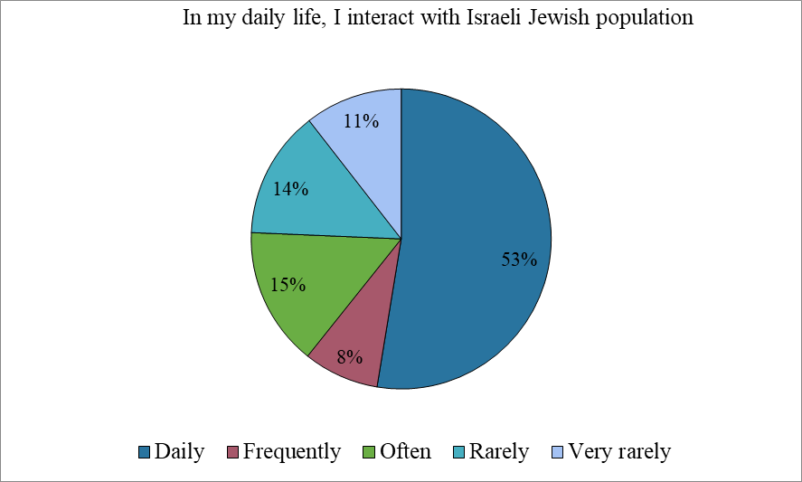

There is a noticeable gender difference in the frequency of interaction: 69% of men reported daily contact with Jews, compared to only 30% of women. In mixed cities such as Haifa and

the central region, 70–80% report daily interaction, in contrast to only 47% in the Galilee and East Jerusalem. Interestingly, the level of interaction does not significantly differ across identity categories.
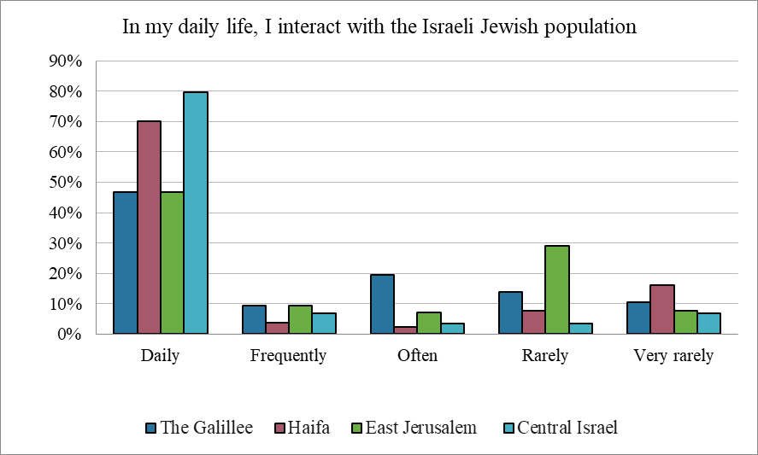

Harassment based on Christian identity does not appear to be a major concern for most local Christians—possibly because such incidents primarily target individuals with a visible religious presence, such as clergy. However, about 20% of respondents from East Jerusalem reported experiencing harassment by Jews due to their Arab or Palestinian Christian identity. In contrast, Christians from the Galilee, Haifa, and central Israel reported such incidents far less frequently.
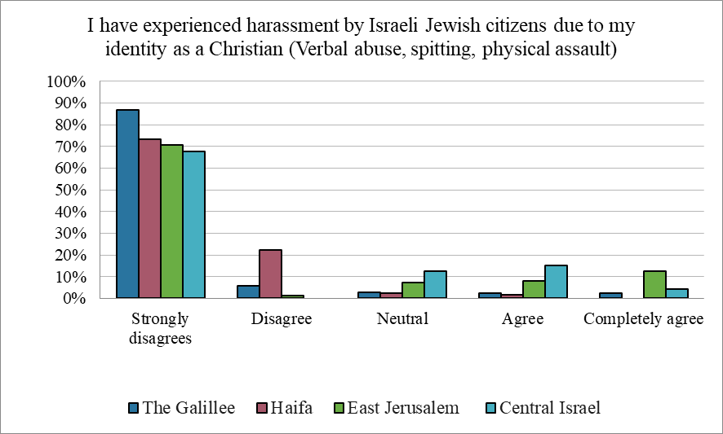

When asked whether they feel comfortable wearing visible Christian symbols, responses varied by region. While the majority across all areas felt safe, over 42% of respondents in East Jerusalem reported feeling uncomfortable—more than double the rate in other regions. This heightened discomfort in East Jerusalem likely reflects the broader tensions in the city,

particularly within the Old City, where religious symbolism and political sensitivities often intersect.
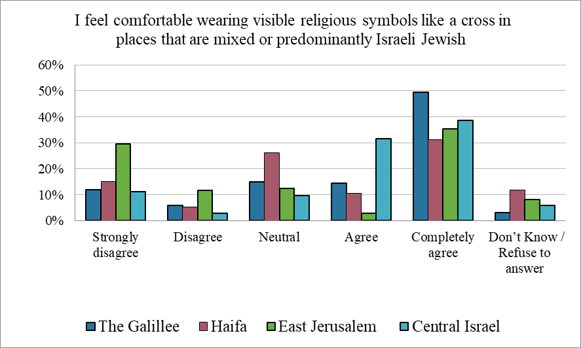

Perceptions of social acceptance by Israeli Jews vary considerably among Arab-Palestinian Christians across different regions. Data indicate that about 31% believe that Israeli Jews accept Arab-Palestinian Christians as part of their society, but regional differences are notable: Christians in the Galilee and central Israel are significantly more likely to perceive acceptance (about 35%) compared to those in East Jerusalem (only 11% feel accepted), while Haifa falls in between at 29% (though only 8% strongly agree). This challenges the notion that mixed cities inherently foster better interethnic relations or reduce friction. Despite the relatively high proportion of individuals in the Galilee who identify as Israeli- Christian (26%), 28% still report not feeling accepted, with 16% strongly disagreeing with the statement: “I feel that Israeli Jews accept Palestinian/Arab Christians as part of Israeli society.”
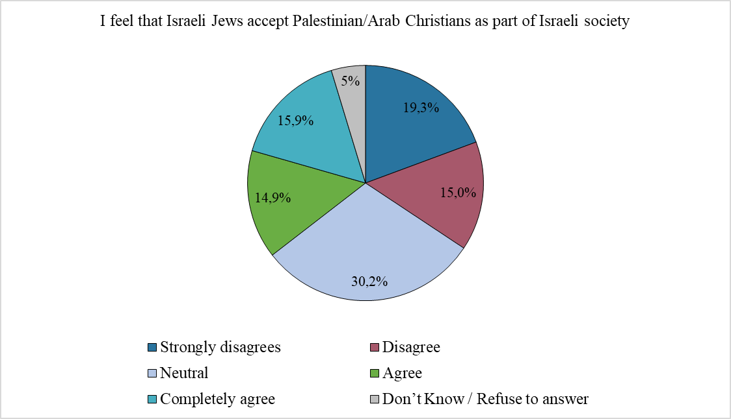

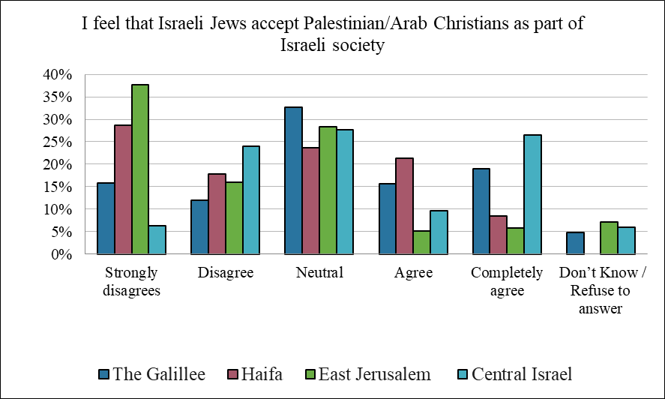
Regarding perceptions of Jewish fear or distrust toward Palestinian-Arab Christians, a plurality of respondents (47%) said they do not perceive the Jewish population as fearful or distrustful of them. When asked whether they believe Israeli Jews differentiate between Muslims and Christians—treating Arab-Palestinian Christians more favorably and thus emphasizing their religious identity—or whether they view them primarily as part of the broader Palestinian-Arab population, responses were evenly split. Notably, Haifa stands out: 48% of respondents there agreed that Israeli Jews treat Christians better than Muslims, suggesting a stronger emphasis on religious identity. In contrast, 46% of respondents in East Jerusalem felt there is no such distinction, indicating they believe Israeli Jews primarily perceive them as Palestinian Arabs.
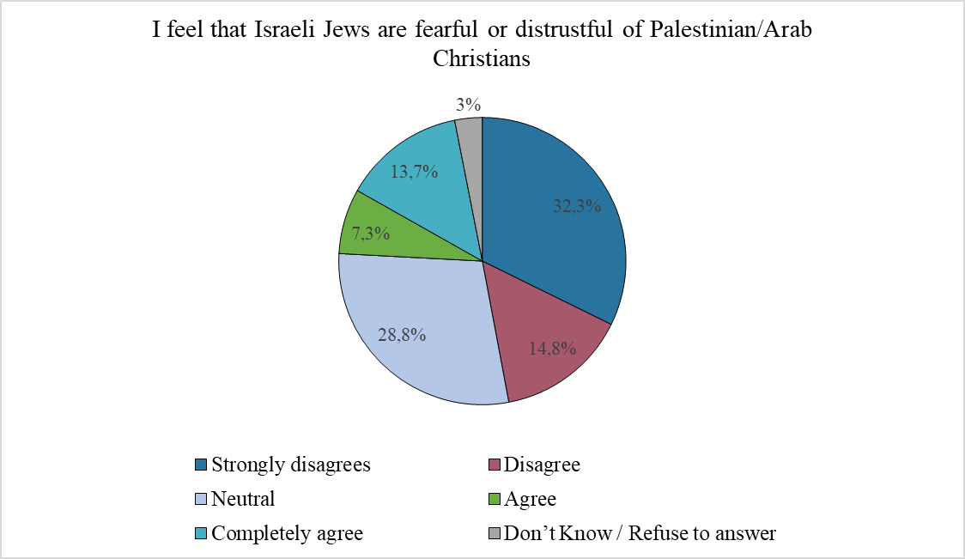

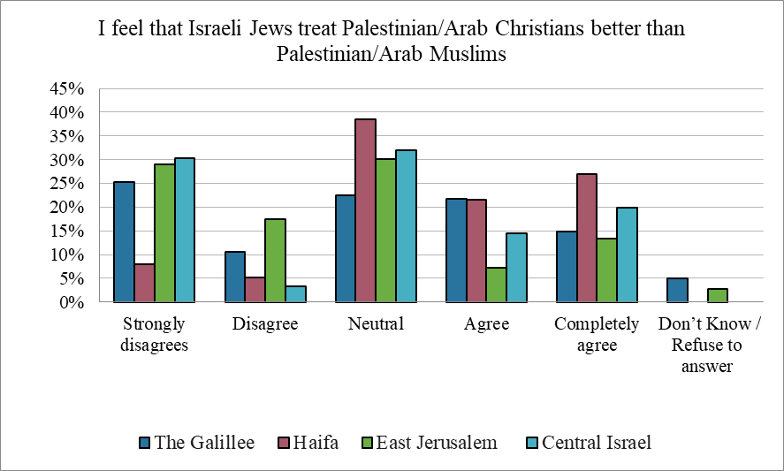

The survey results also suggest that Arab-Palestinian Christians feel Israeli Jews show limited interest in learning about or engaging with their communities: 44% disagreed with the statement that Israeli Jews are interested in learning more and engaging with them, while 28% remained neutral. Younger respondents, in particular, appeared more skeptical about the level of Israeli interest and engagement.
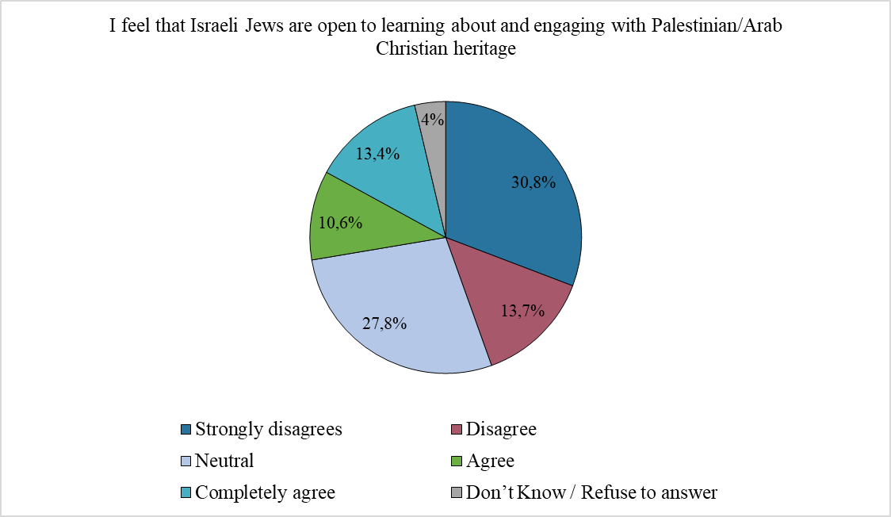

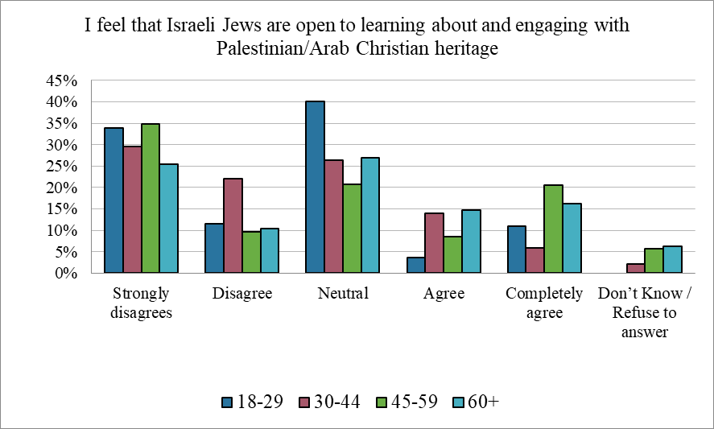

Relationship with the State:
The way Arab-Palestinian Christians relate to the state offers important insights into their broader social and political positioning. This relationship is shaped by views on key national policies such as the Nation-State Law, willingness to send their children to military service, and perceptions of access to opportunities and representation within state institutions.
Regarding the sense of freedom of expression and the protection of basic rights—such as access to education, healthcare, and other services—60% of respondents agreed that these rights are guaranteed by the state and its institution. Nearly half agreed that they receive fair treatment from municipal services, with significantly higher agreement (almost 80%) reported in the central region.
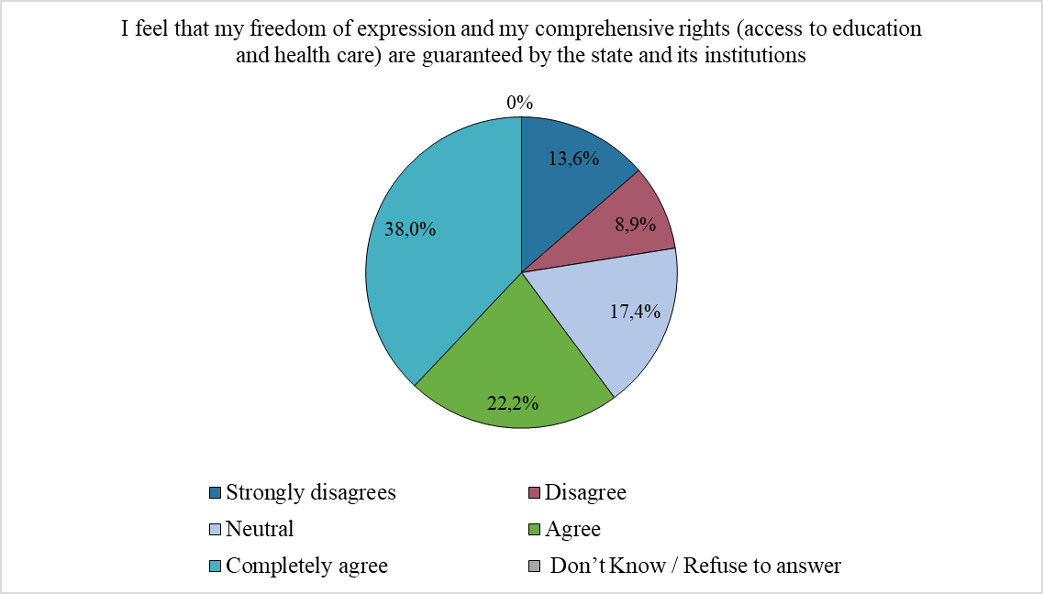

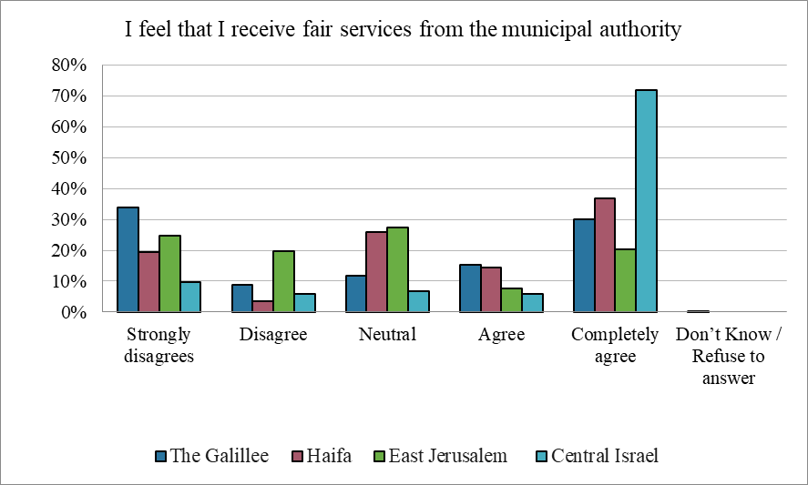

When asked whether their Palestinian/Arab Christian identity affects their access to employment opportunities and chances for advancement within state institutions, about one-third of respondents said it does have an impact, while 40% felt that it does not.
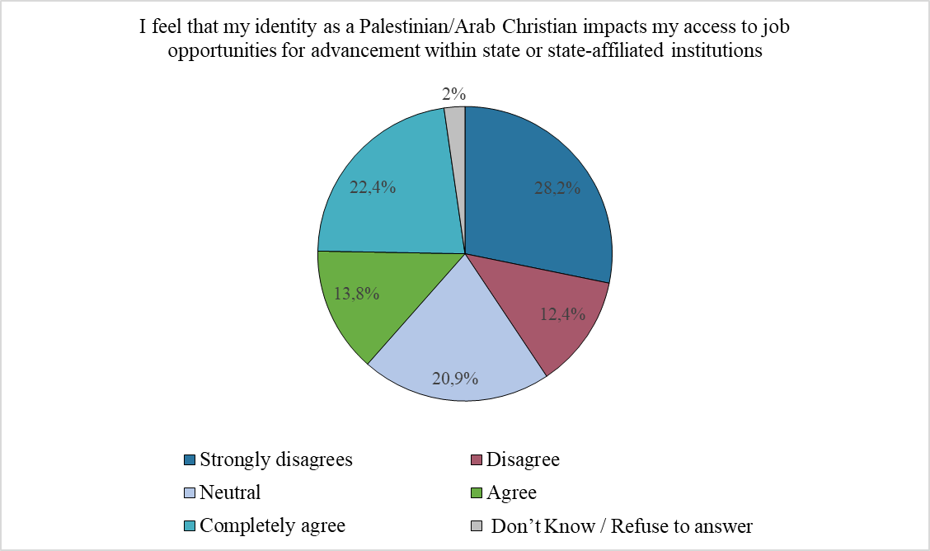

72% of survey respondents said they feel that their freedom of religion and worship is upheld without interference, and that they have not experienced harassment by state institutions or their representatives due to their Arab/Palestinian Christian identity.

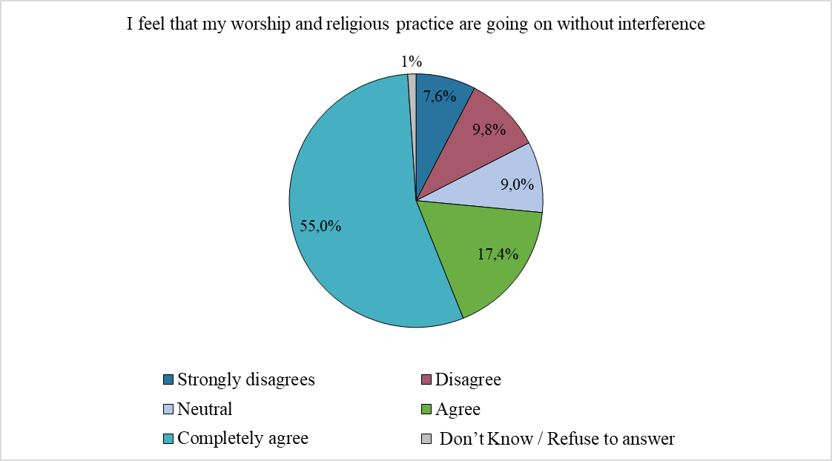
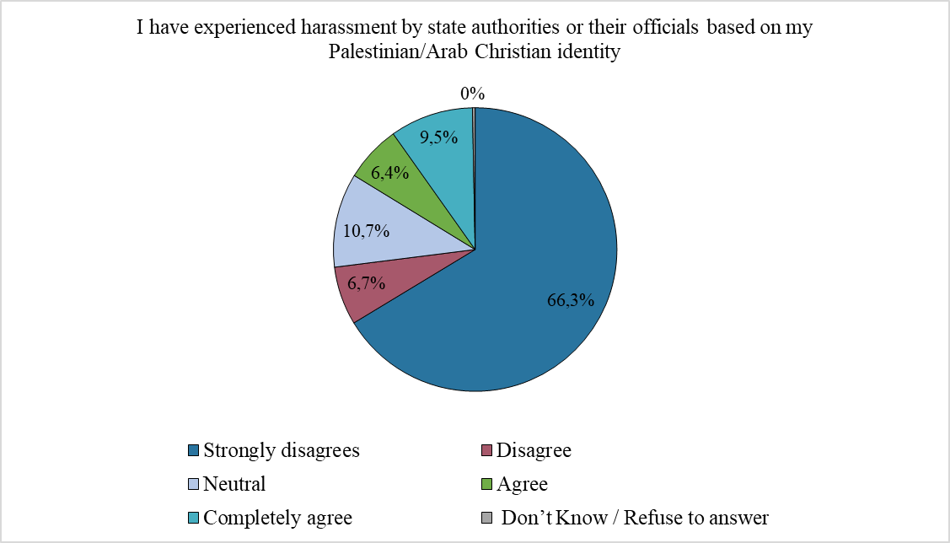

However, in East Jerusalem, this number drops sharply: only 29% feel that their freedom of religion and worship is respected and nearly 40% reported feeling perceived restrictions on religious freedom, and slightly fewer said they had experienced harassment due to their identity. This disparity may be linked to the intensive interaction between Christian communities in Jerusalem and state authorities, especially around major religious ceremonies at holy sites, processions, and large public events such as Holy Week and the Holy Light celebrations.

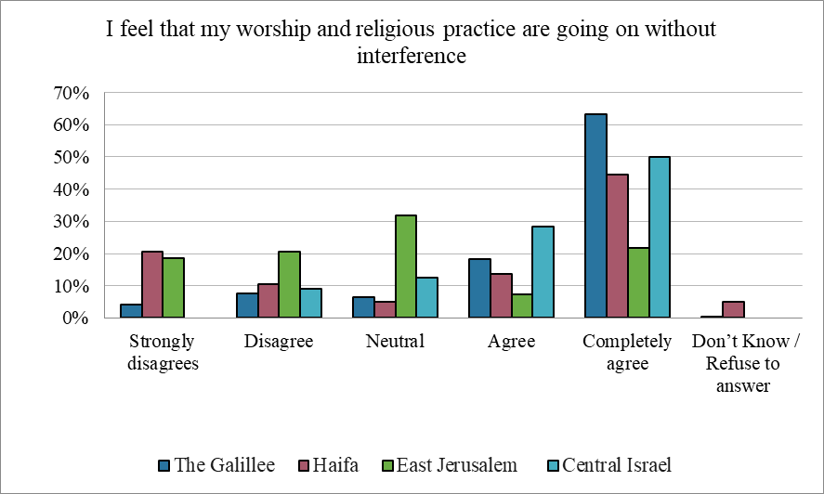

The survey indicates that the Nation-State Law has contributed to widespread feelings of inequality and injustice among minority groups in Israel, including Arab/Palestinian Christians. The Nation-State Law, enacted in 2018, was not perceived as a significant shift in how Israelis view the State of Israel, and many considered it merely declarative, with no practical implications, however 51% of respondents believe that the 2018 law has had a tangible impact on their daily lives, and 64% feel that it reinforces their status as second- class citizens, with 47% strongly agreeing with that sentiment.
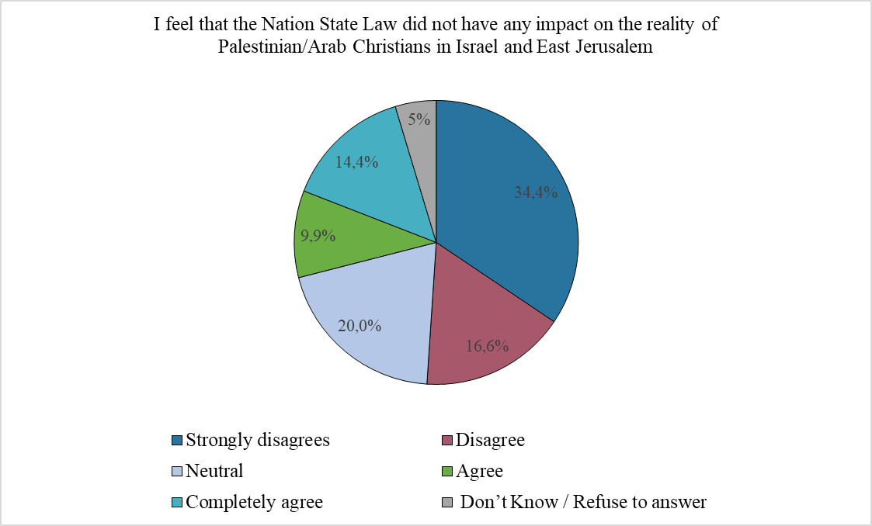

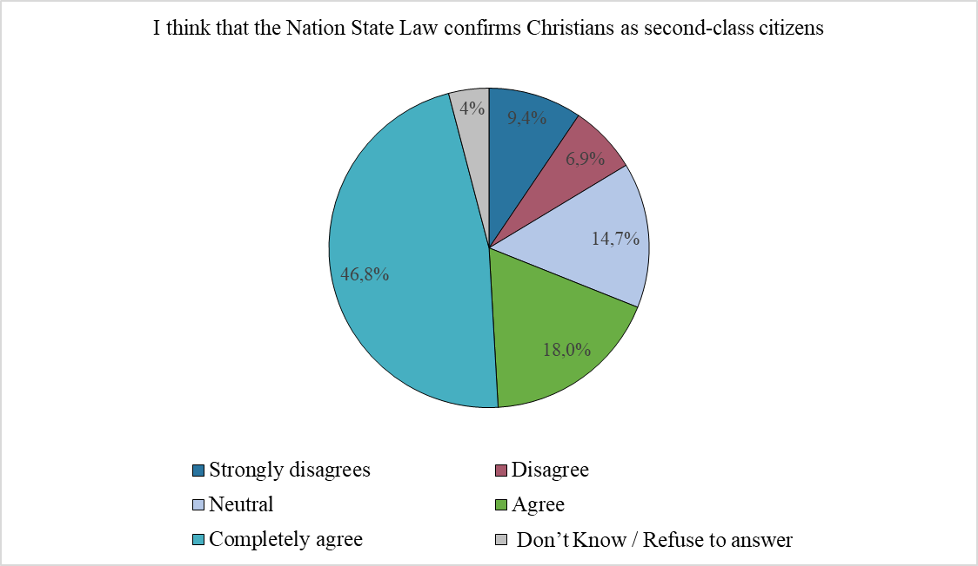

As part of the survey, respondents were also asked about their attitudes toward military and national service. Although Arab-Palestinian citizens are not subject to mandatory conscription into the Israeli army, they are allowed to volunteer. In the survey, a clear majority—70.6%—disagreed or strongly disagreed with the idea of their children serving in the army. Only 17.8% agreed or strongly agreed with this statement, with 12% strongly agreeing. Similarly, when asked about participation in national civilian service, 49% of respondents disagreed or strongly disagreed with their children joining, while 36% expressed support for participation in such service.
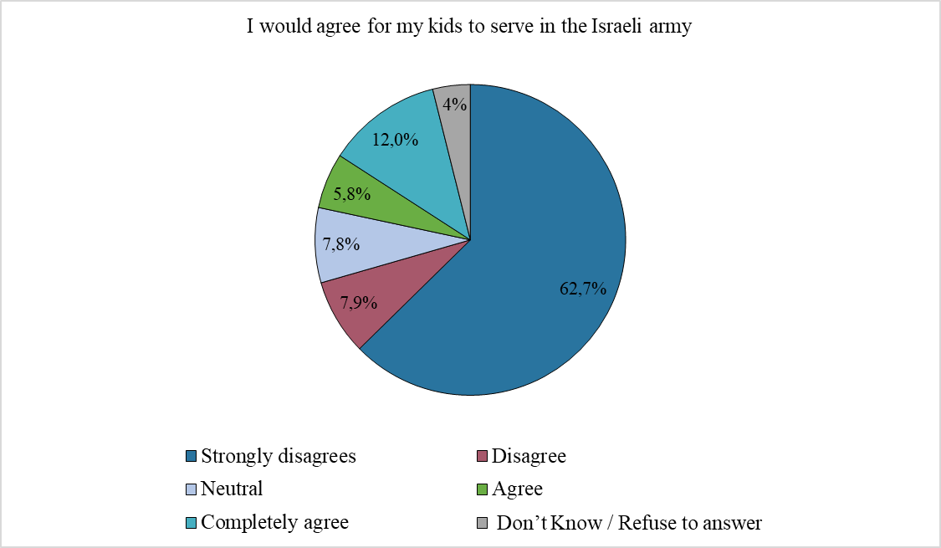

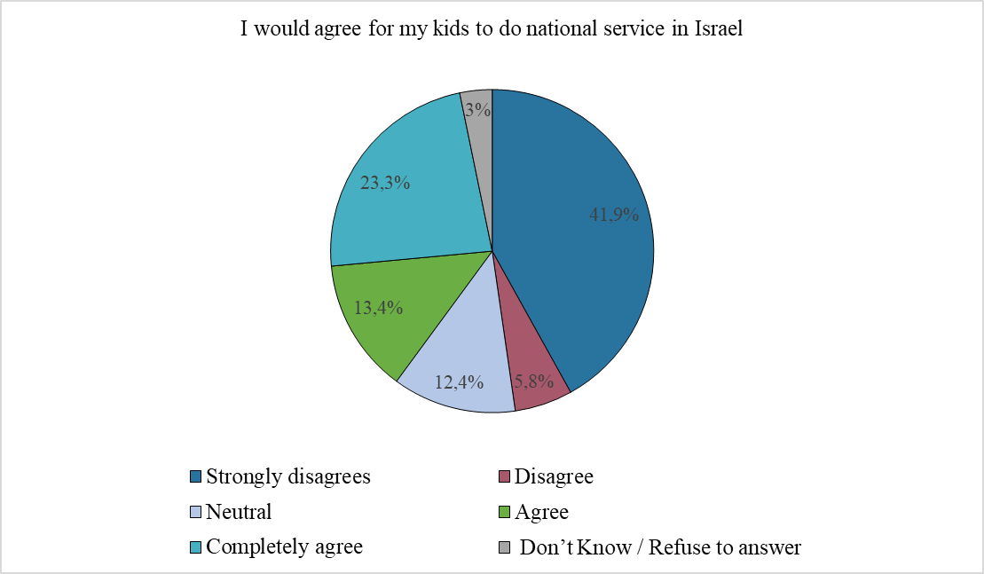

Relationship with the Church

Church engagement among respondents is notably high: around half report occasional participation in church activities, and a third are regularly involved. Only one in seven indicated no involvement at all—meaning that 85% take part in church life to some extent. Particularly striking is the involvement of young people: 40% of them are regularly active, a higher rate than in any other age group, pointing to strong youth engagement in church- related activities.
It is important to note that "church involvement" extends far beyond Sunday services, religious rituals, or spiritual guidance. In many communities, churches serve as the central hub for social, educational, and cultural life. They operate schools—attended by almost all Christian children, regardless of how religious the curriculum is—as well as offer cultural programs, informal education for children, activities for elderly, women, volunteering opportunities, and even sports clubs and youth movements.
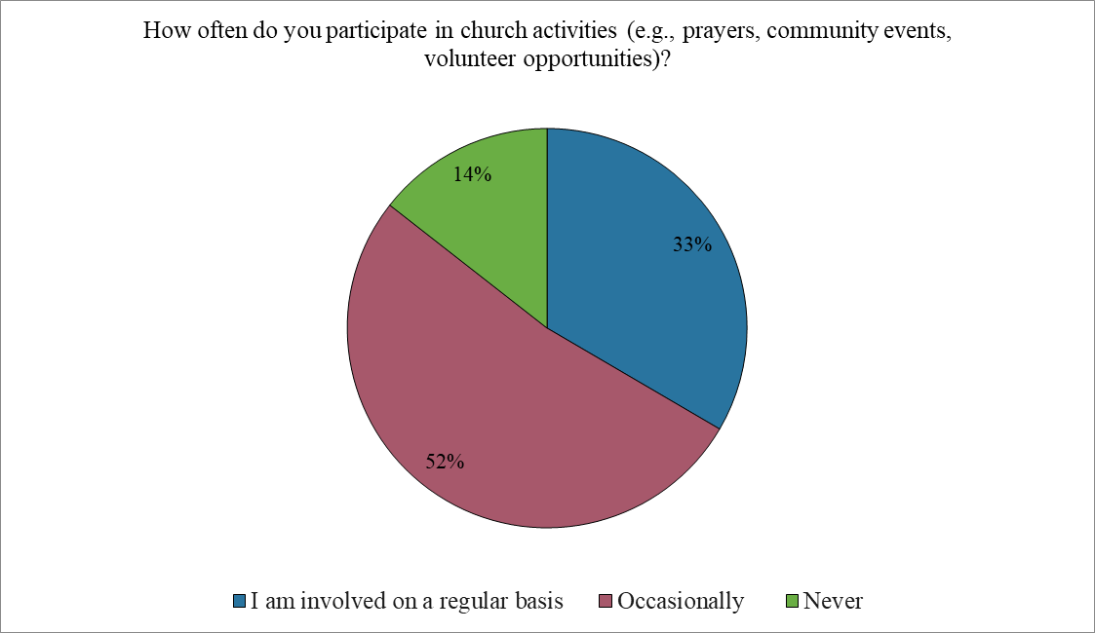

No significant gender differences were observed in the level of participation in church activities. In Haifa, only 17% of respondents are regularly involved, suggesting that the community engages primarily for religious purposes rather than for social support. In contrast, in Jerusalem, about half of the respondents participate regularly, likely due to the church’s broader role in providing social, educational, and communal services.
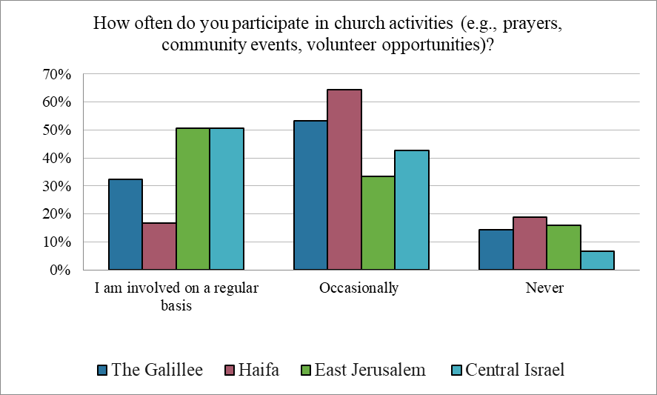

Opinions on whether the church meets people's needs for spiritual guidance and personal support are divided. Younger respondents are slightly more likely to feel that their spiritual needs are being met, while older groups are less convinced. Women report slightly higher satisfaction (60% vs. 47%). In Haifa, fewer than 7% completely agree that their spiritual needs are met, and 38% strongly disagree. However, when including those who gave moderate responses (agree or disagree), the overall results align more closely with other regions. This aligns with the earlier finding that church involvement is significantly lower in Haifa, where the church appears to play a less central role in community life.
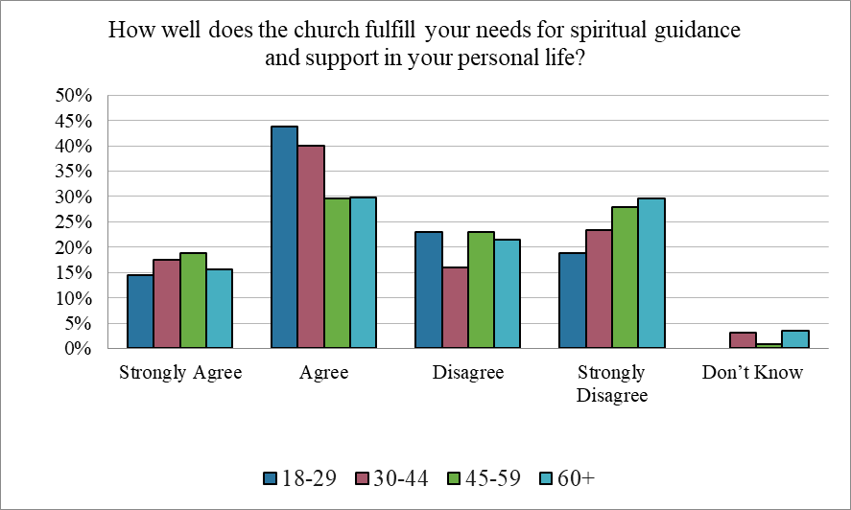

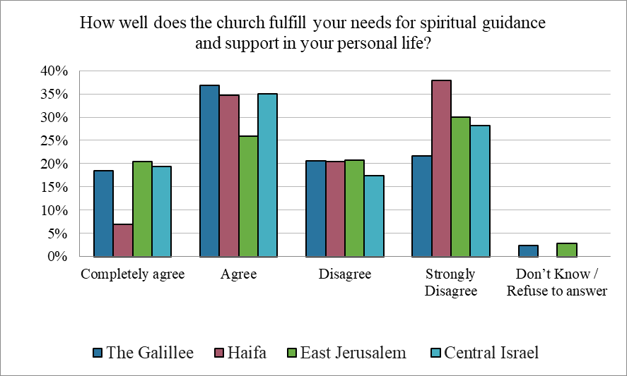

A majority of respondents (46%) disagree that the church adequately addresses the needs of Palestinian Arab Christian communities, compared to only 26% who believe it does. Views differ across age groups, with respondents aged 45–59 expressing the highest level of agreement. Gender differences are also evident: 32% of women feel their needs are being addressed, compared to only 22% of men.
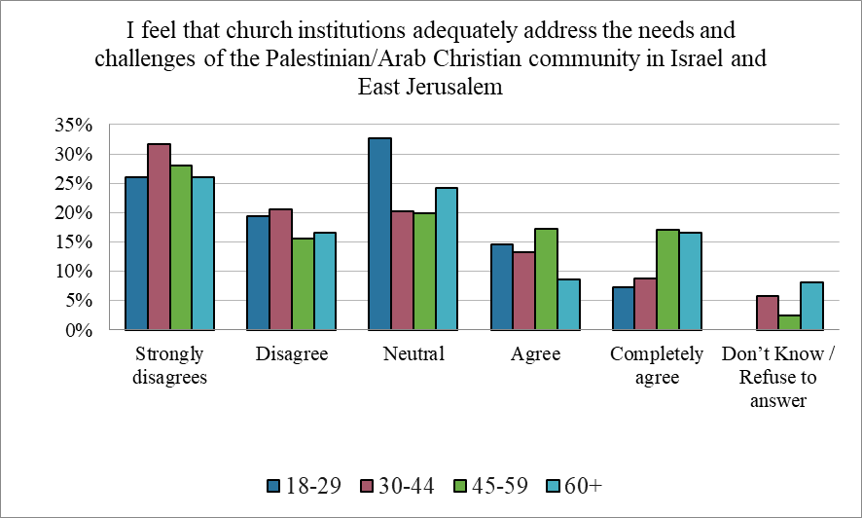

Regionally, respondents from the Galilee report a more favorable assessment of the church’s role, whereas dissatisfaction is more pronounced in Haifa (58%), Jerusalem (50%), and especially in the central region, where two-thirds believe their needs are not being met.

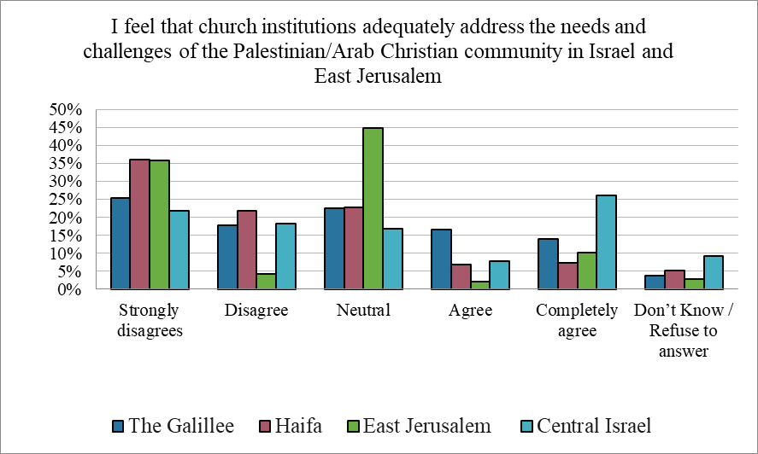

The question of how the Church can effectively contribute to preventing emigration cannot be answered uniformly; rather, it must be examined in relation to the specific challenges faced in each region. In Jerusalem, the housing crisis emerges as the most urgent concern (53%), followed by the protection of church-owned properties (29%)—likely reflecting fears that land is being acquired or taken by non-Christian actors, a phenomenon increasingly common in the areas surrounding the city. In Haifa, employment is the primary concern (39%), while in the central region, both land ownership and housing are prominent issues (37%), possibly due to the particularly high cost of housing in central Israel.
Personal security and education are not widely seen as areas where the Church should intervene in order to prevent emigration. Despite the widespread presence of church-run schools, education was rarely cited as a major concern. This suggests that while the Church’s role in education remains stable, it has not significantly influenced emigration trends.
Employment-related concerns are most prominent among respondents aged 45–59, likely reflecting anxieties about their children’s economic future. Notably, 13% of respondents aged 60 and above expressed no expectations from the Church at all.
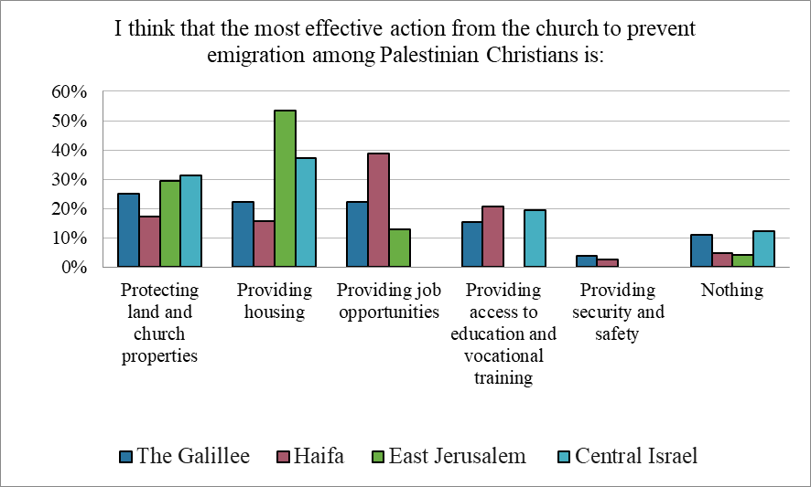

These findings indicate that while local priorities differ, the Church can play a vital role in addressing economic pressures—particularly those related to housing and employment—in order to support Christian communities and reduce emigration. Furthermore, the protection of church-owned property is a growing concern for many, as it might be seen as a potential resource to alleviate the housing crisis and to secure the future of both the community and the Church’s institutional presence.

- Outlook on the future:

Despite various challenges, the majority of Arab-Palestinian Christians do not currently consider emigrating. More than half cite family ties as the primary reason for staying. Overall, 64% of respondents expressed a desire to remain, while 36% are considering leaving. The possibility that a third of this minority group might eventually emigrate raises concerns about the long-term sustainability of the Arab-Palestinian Christian presence in Israel. Younger generations appear more inclined to emigrate: 48% of respondents aged 18–29 and 52% of those aged 30–44 reported that they are considering leaving.
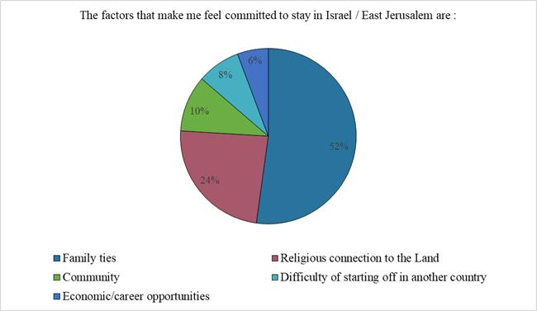
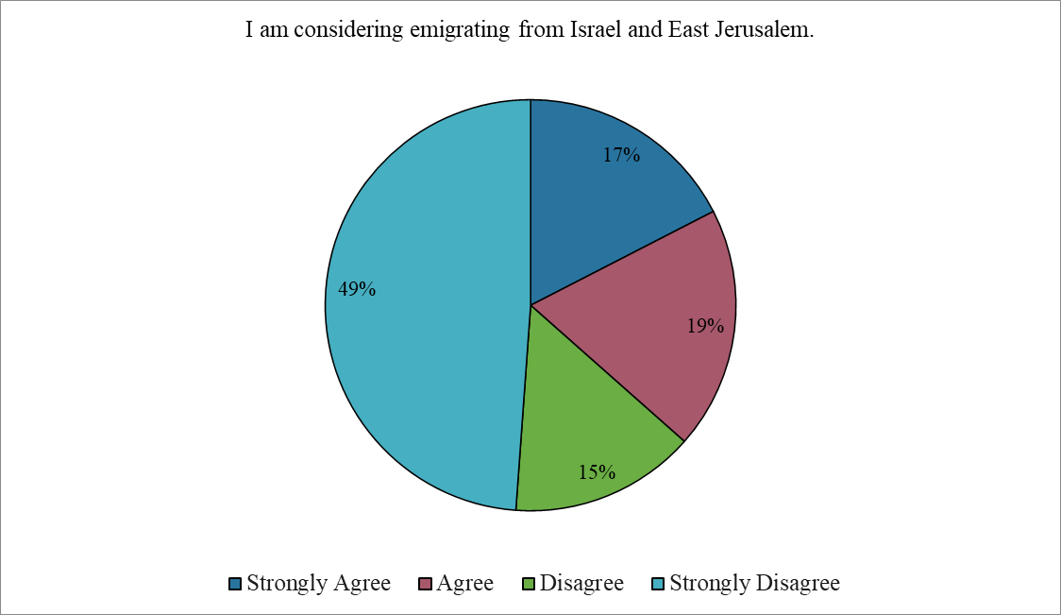

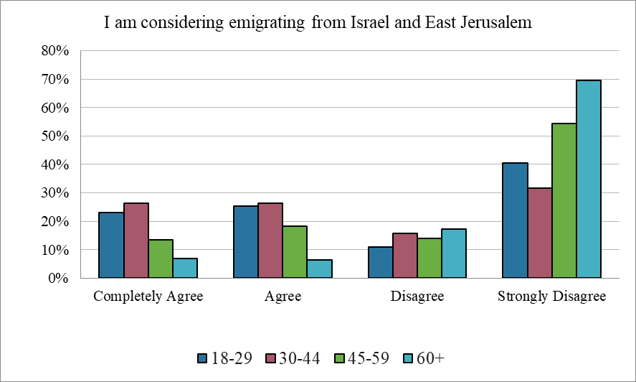

Regional variation is also notable. In Haifa, 30% of respondents strongly agreed with the statement that they are considering emigration. In contrast, in East Jerusalem, 70% strongly disagreed—and when including those who somewhat disagreed, the figure rises to 84%, indicating a strong commitment to remain.
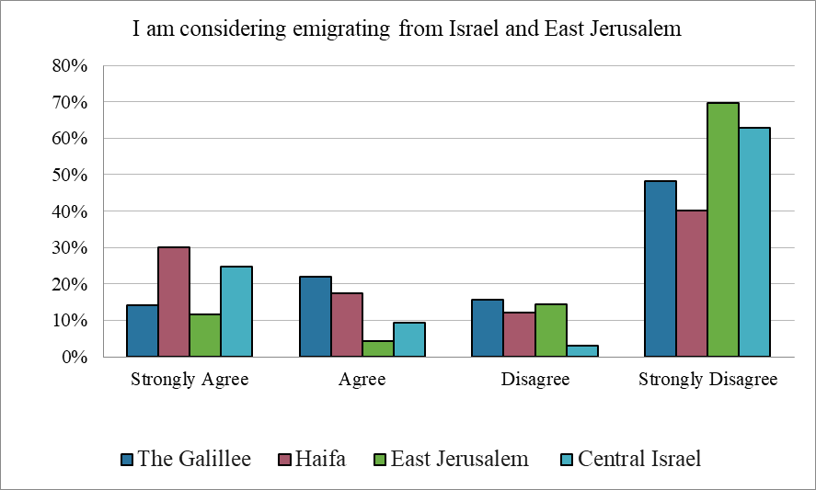

The leading reason given by those considering emigration is concern about personal security and exposure to violence, particularly among younger respondents (62%). Socio-political factors are the second most frequently cited reason, especially in central Israel and even more so in East Jerusalem, where 81% of those considering emigration identified them as a major influence on their decision.
These differences reflect the distinct realities and challenges faced by Arab-Palestinian communities in different regions. In the Galilee and Haifa region, rising levels of criminal violence within Arab society—with increasing numbers of incidents and fatalities each year— have made personal security the central concern. A widespread perception that the

authorities have failed to seriously address crime in Arab communities only intensifies this sense of insecurity.
By contrast, in East Jerusalem, political issues dominate: the lack of equal citizenship for Palestinian residents, discriminatory policies, and the broader political climate all contribute to a strong sense of marginalization and are key drivers of emigration considerations. Still, many respondents in East Jerusalem emphasized their religious and communal connection to the land as a key reason for staying. Lastly, when considering issues regarding emigration, it is important to note the distinction between East Jerusalem residents without Israeli citizenship and Palestinian citizens of Israel: East Jerusalemites risk losing their residency status if they relocate abroad, whereas Palestinian citizens of Israel retain their citizenship even if they choose to live outside the country.
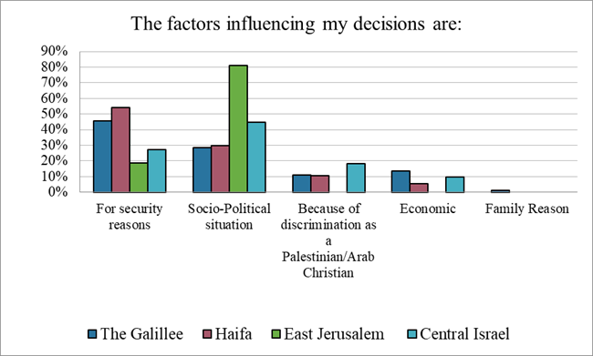

When asked specifically about their children's future, 42% of respondents said they hope their children will remain in Israel and East Jerusalem. In Haifa, more parents indicated they would encourage their children to emigrate, while in central Israel, fewer expressed such a view.
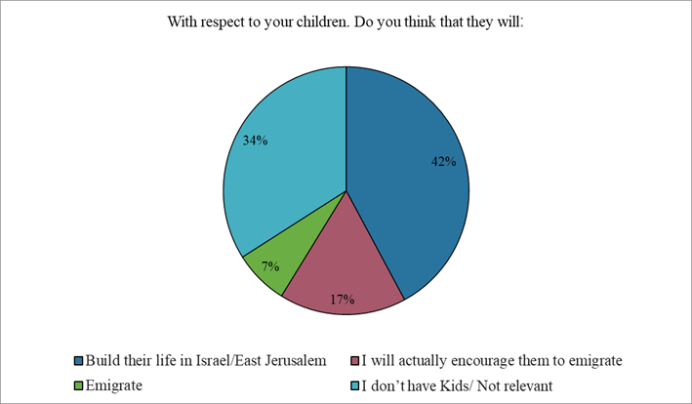

When asked what would make them more hopeful about the future in Israel and East
Jerusalem, respondents’ answers varied by region. In the Galilee, the top priority was
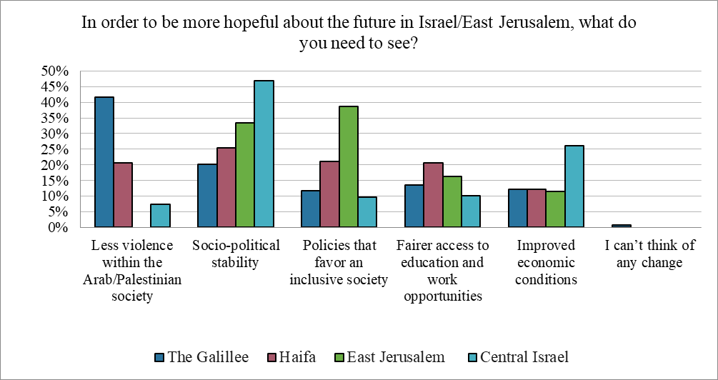
reducing violence within Arab-Palestinian society, cited by 42% of respondents. In the central region, 47% identified socio-political stability as the most important factor. In East Jerusalem, respondents emphasized both socio-political stability (33%) and the promotion of a more inclusive society (39%) as key to fostering hope. In Haifa, responses were more evenly distributed, with participants highlighting a combination of socio-political stability, greater inclusivity, equal employment opportunities, and improvements in the education system as important areas for change.

- Definitions of Identity

Identity can be understood along two key dimensions. The first is the centrality of Christianity to personal identity, with 77% of respondents viewing it as a core element of who they are. The second-dimension concerns how individuals position themselves within broader ethnic and national categories—such as Palestinian, Israeli, or Arab. A third of respondents identified themselves as Arab Christians, while just under a quarter defined themselves as Israeli Christians. One in seven (13%) described themselves as Palestinian Christians, and an additional 9% identified simply as Palestinian, without a religious designation. It appears that identifying as a Christian does not necessarily reflect religious belief or involvement in church activities, as nearly a quarter of those who defined themselves as Israeli -Christians reported that they rarely participate in church-related activities.

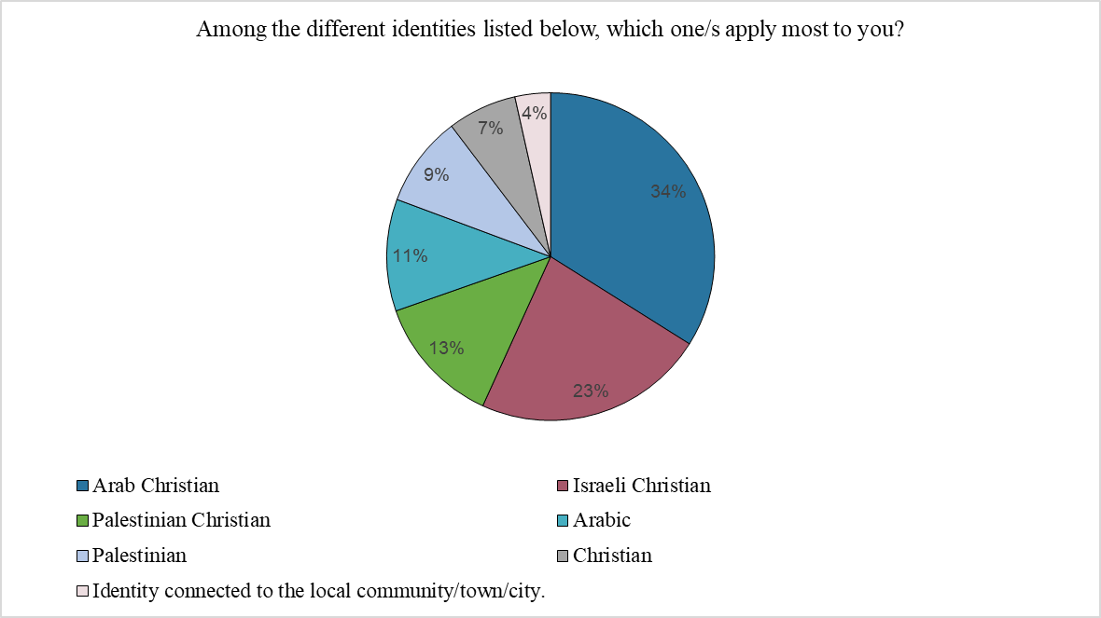
Identity varies notably across different regions. In the Galilee, significantly fewer Christians incorporate a “Palestinian” identity into their self-definition—only 16%, compared to over 36% in other regions. Christians in both the Galilee and the Central region are more likely to accept being described as Israeli. The Central region is particularly noteworthy, as both “Israeli” (22%) and “Palestinian” (30%) are common self-identifications, reflecting a clear divide in how identity is perceived within this area.
In Haifa, there is less emphasis on Christian identity, which may be linked to a stronger identification as Arab or Palestinian in contrast to the broader Israeli population, as well as to lower levels of connection to and involvement in the Church. In East Jerusalem, 18% of respondents define themselves solely as Christian, without attaching a national or ethnic component to their identity.
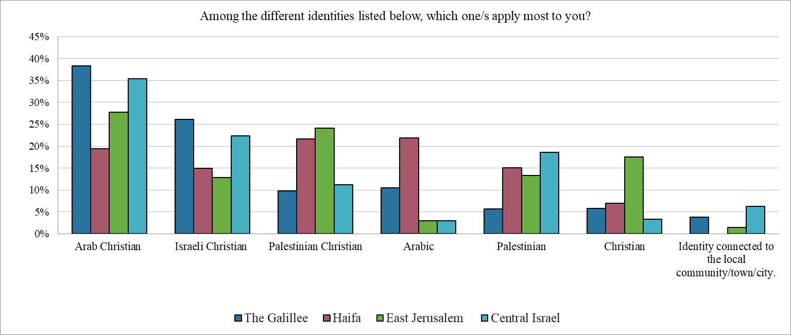

When analyzing identity by age, "Arab Christian" remains the most common self-description across all age groups. However, younger respondents are less likely to identify as "Israeli Christian" or solely as "Arab." Among those aged 18–29, there is a notable increase in identification as either "Christian" or "Palestinian." This move away from citizenship-based labels and from the more neutral term "Arab" toward more distinct religious or national identities may reflect a growing sense of separation from the Jewish Israeli majority culture.
This shift could be influenced by an increasingly challenging political climate for minorities. The sharp decline in identification with the term "Israeli" among respondents under 45, compared to older generations, may be driven by low expectations for the future, disappointment in the possibility of shared life with Jewish Israelis, and growing disillusionment in light of recent political changes in Israel.
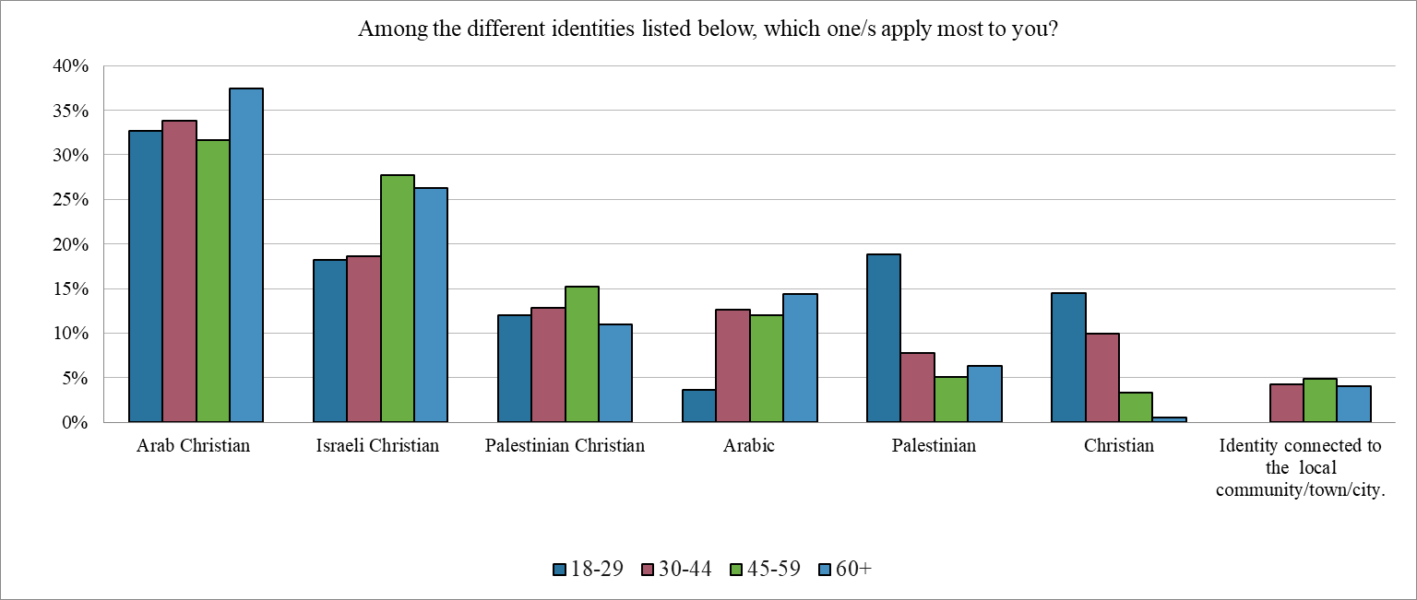

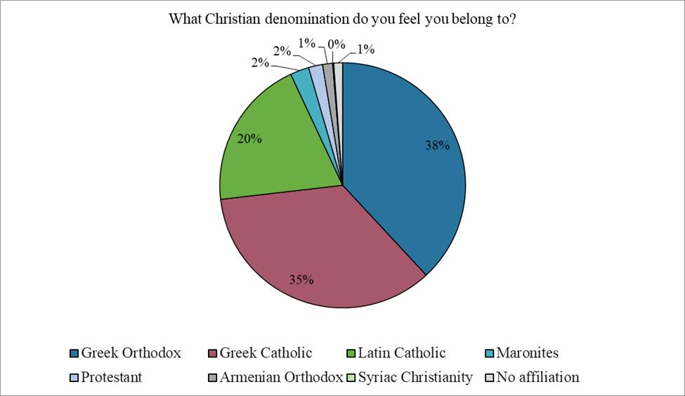

Methodology:
The survey was conducted in December 2024 by the polling company Statnet. It had been a year since the war in Gaza, which had created broad tensions within Israel and East Jerusalem, as well as the heavy bombardment of the Galilee due to the Hezbollah-Israel war. A ceasefire with Hezbollah was in place during the survey period, while the war in Gaza was still in an active fighting phase with no concrete perspective of ceasefire.
The survey included a sample of 315 respondents from the Christian community in the Arab community, the possible error rate ranges between ±5.5%.
The database preparation process was carefully done to ensure that the study sample represents the target group. The sample was randomly selected taking into account the geographical distribution of the target group, in addition to the distribution by age groups and gender. The denomination affiliation is also represented in the survey. The survey consisted of a questionnaire of 29 questions, throughout telephone interviews.
The sample included 214 Christians from Galilee, 41 from Haifa, 30 from central Israel, and 30 from East Jerusalem. It included 179 males and 129 females.

Appendixes:
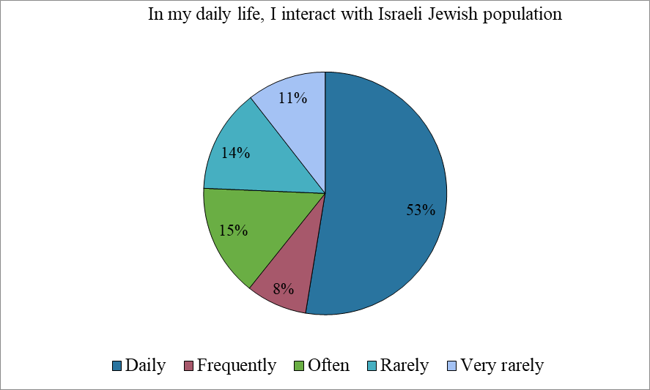

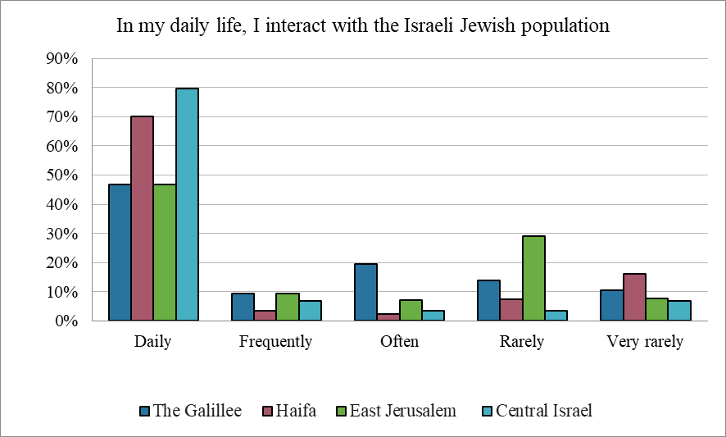

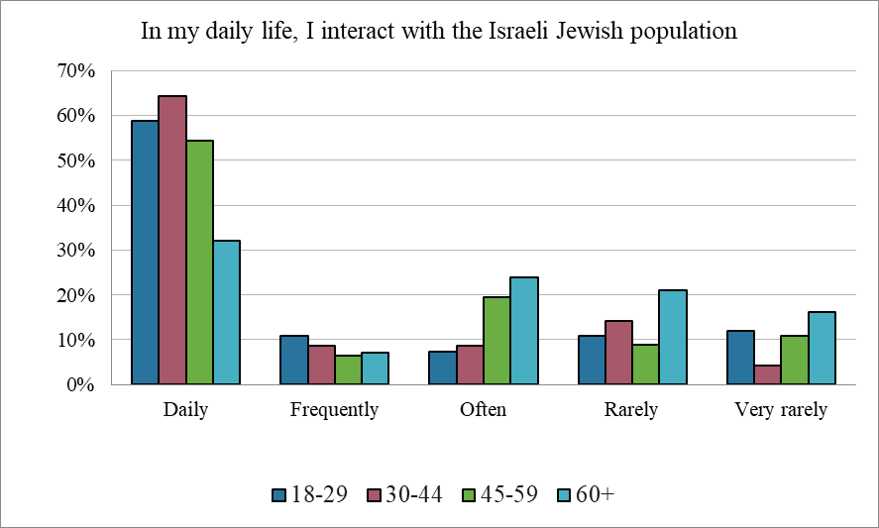

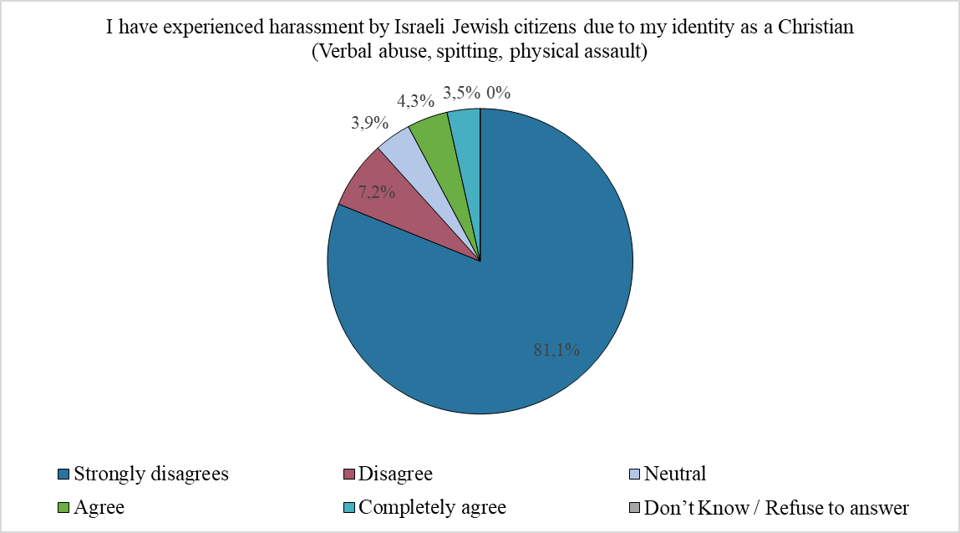

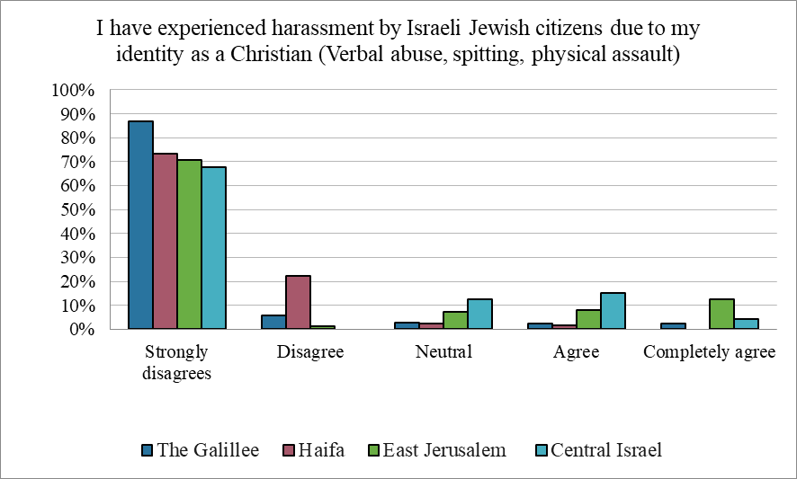

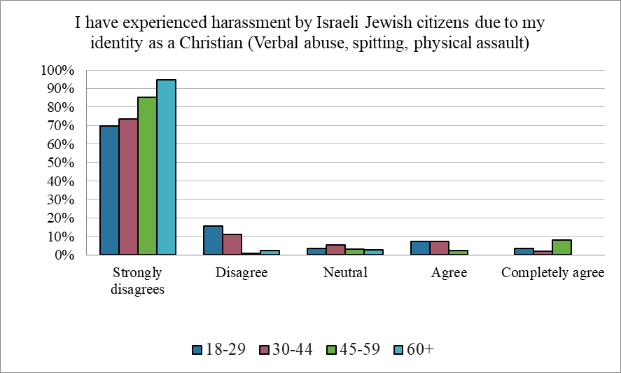

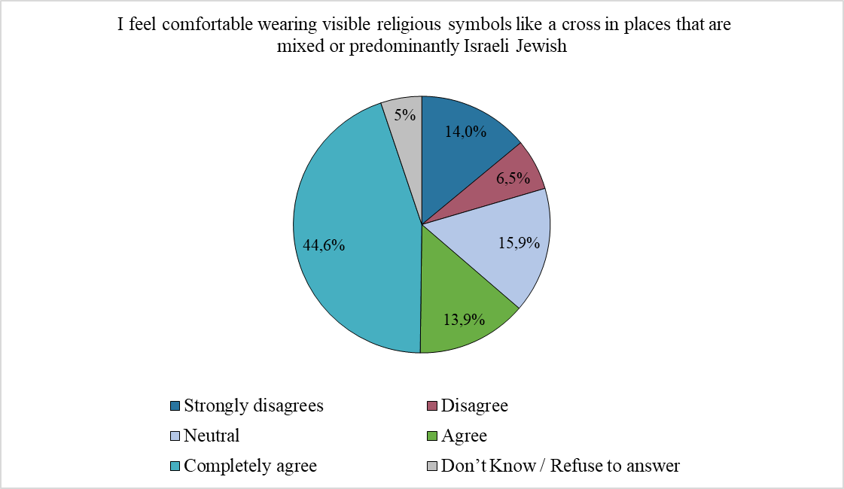

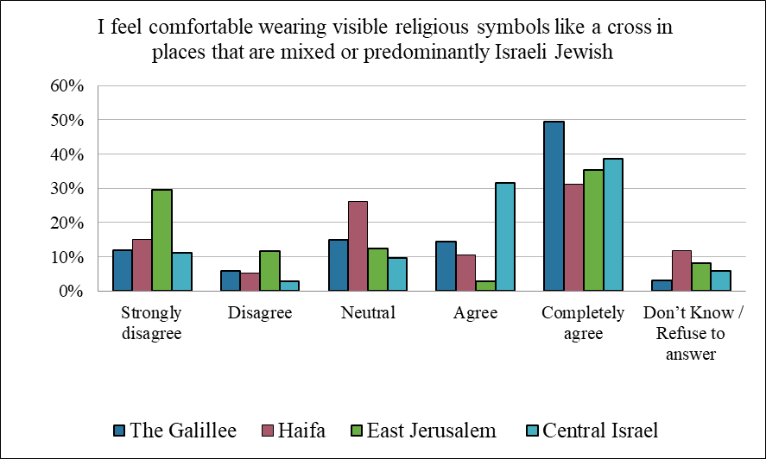

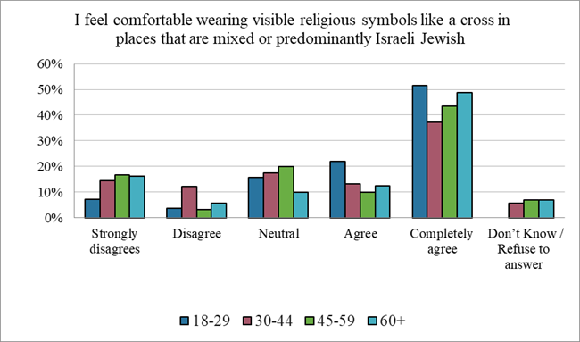

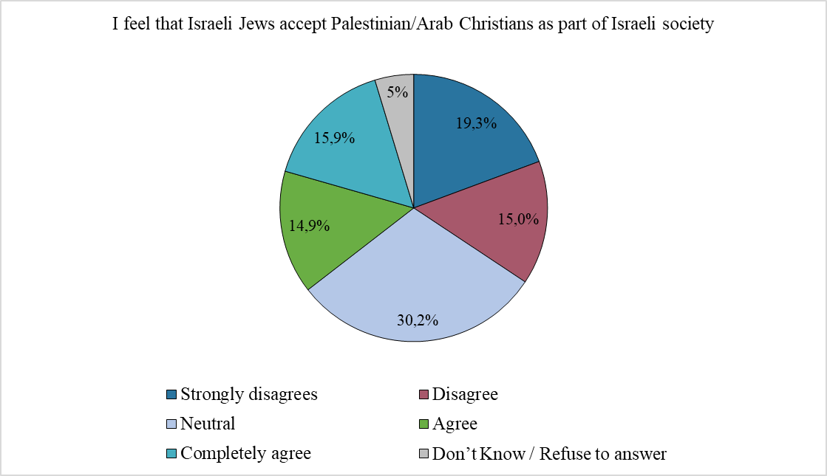

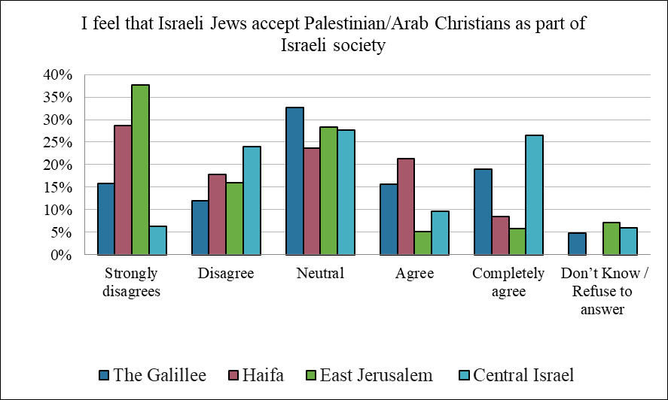

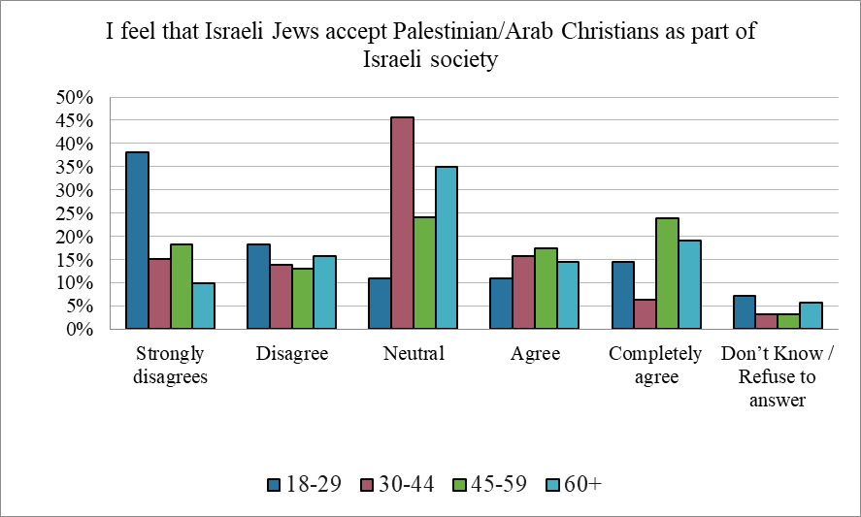

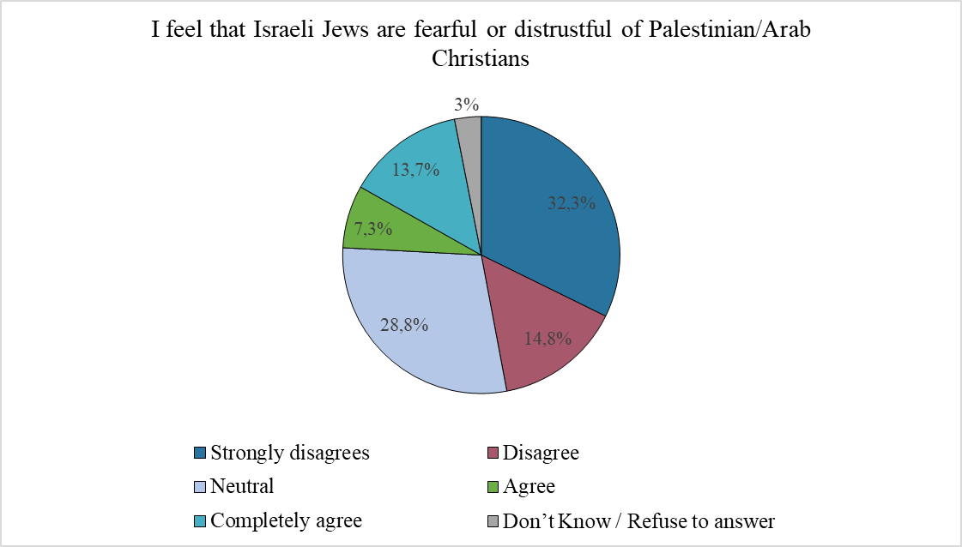

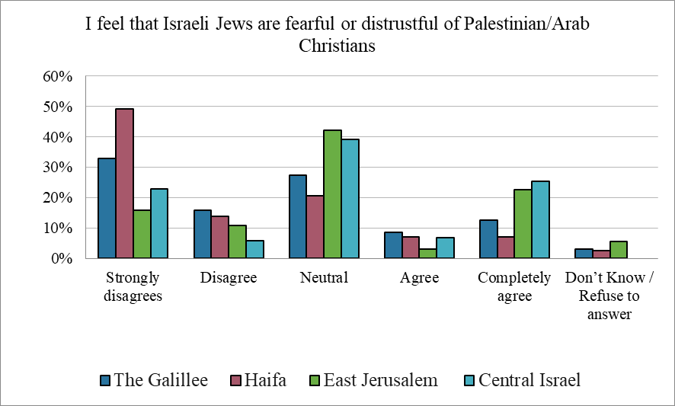

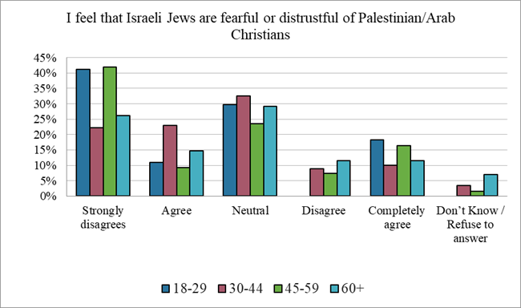

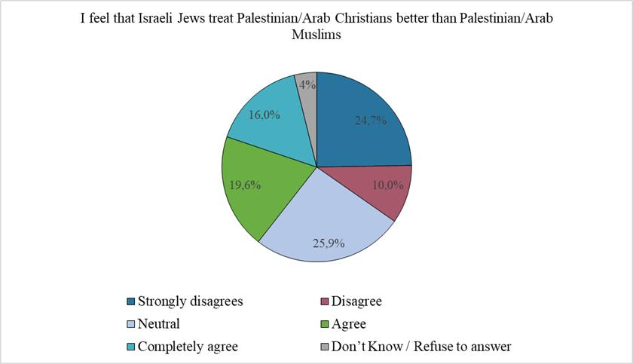

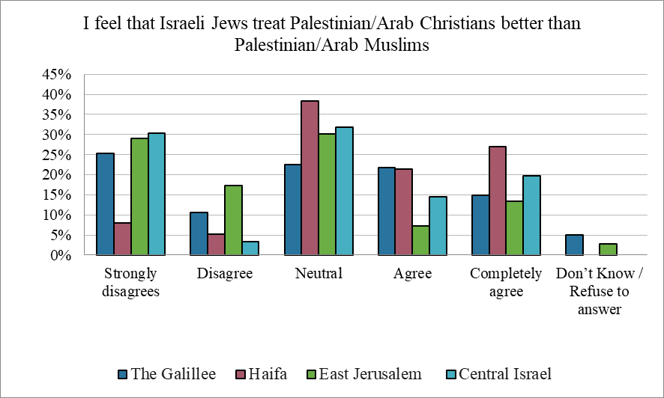

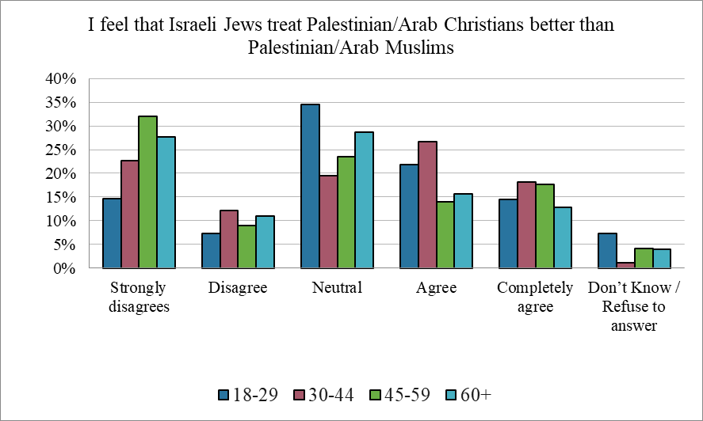

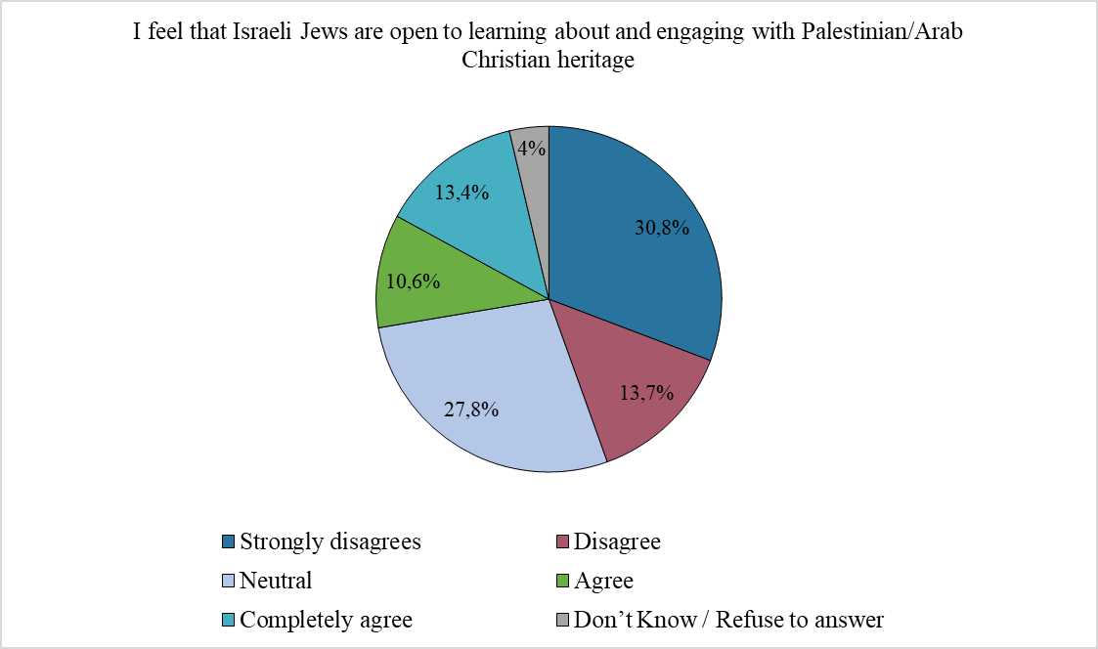

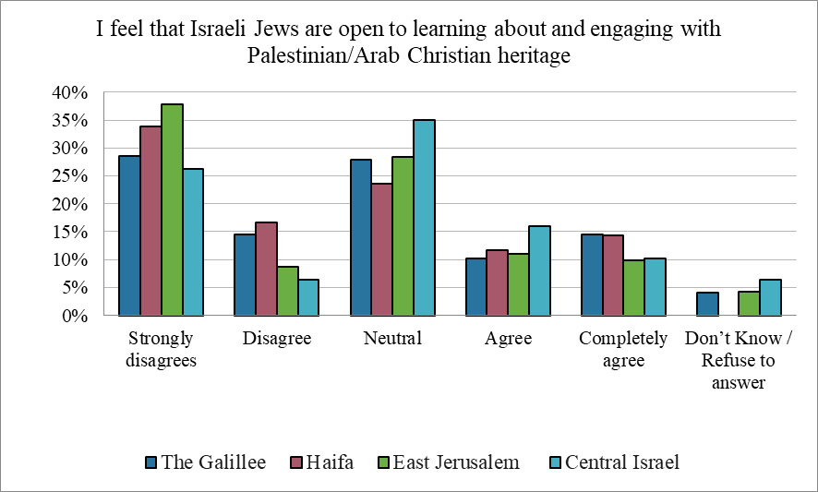

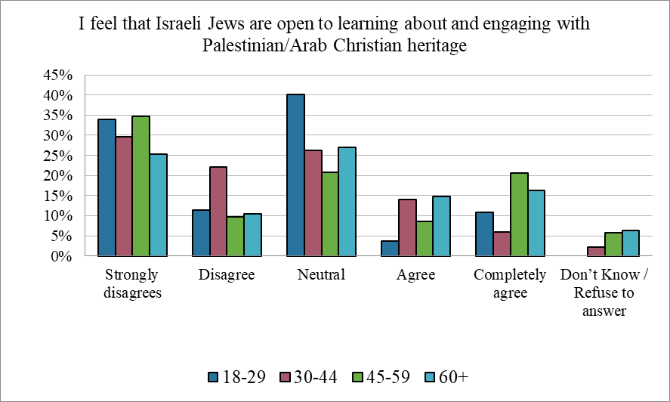

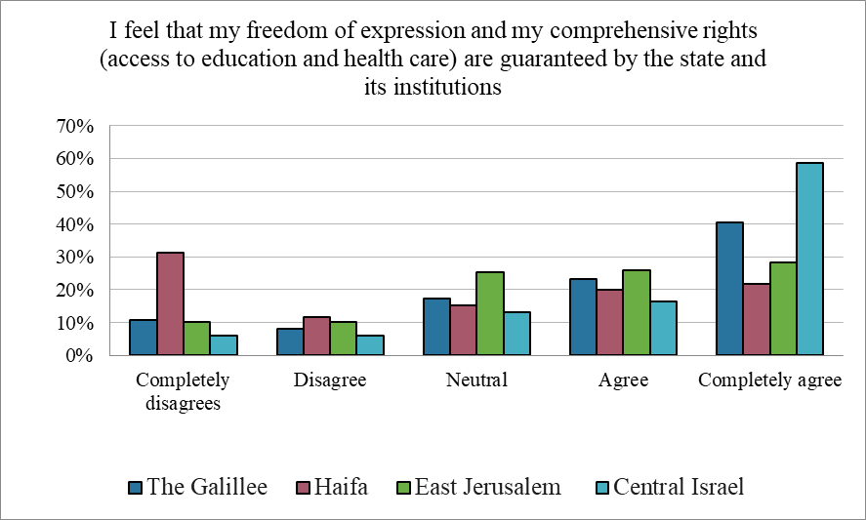

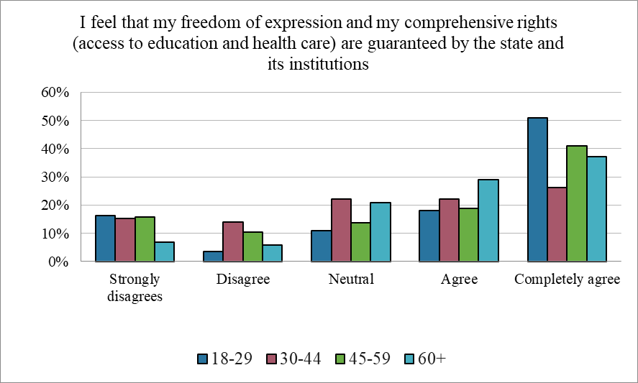

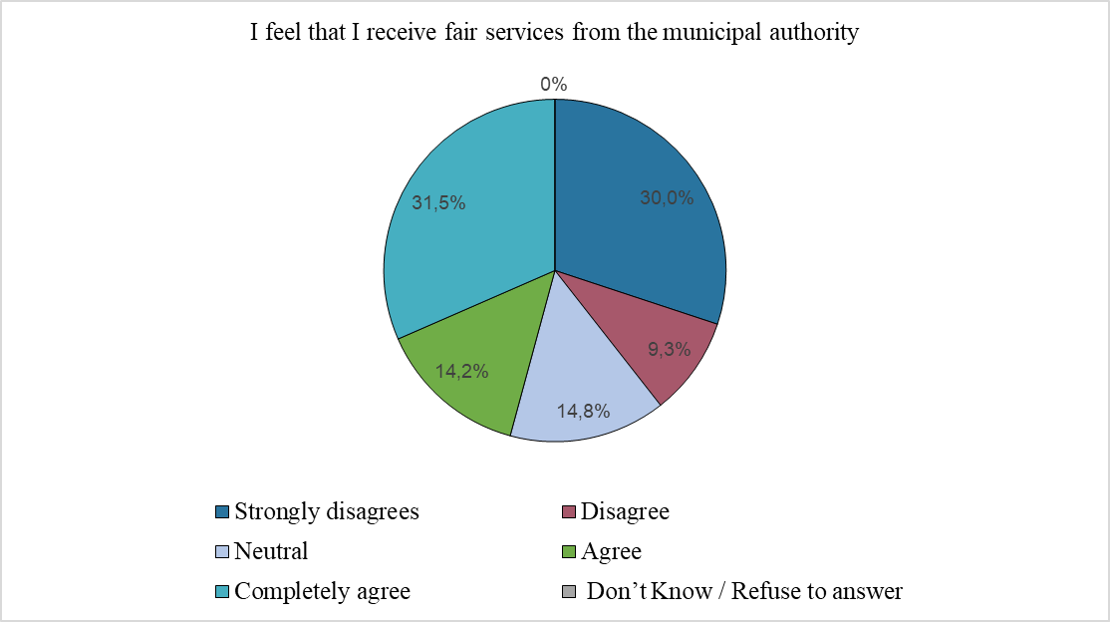

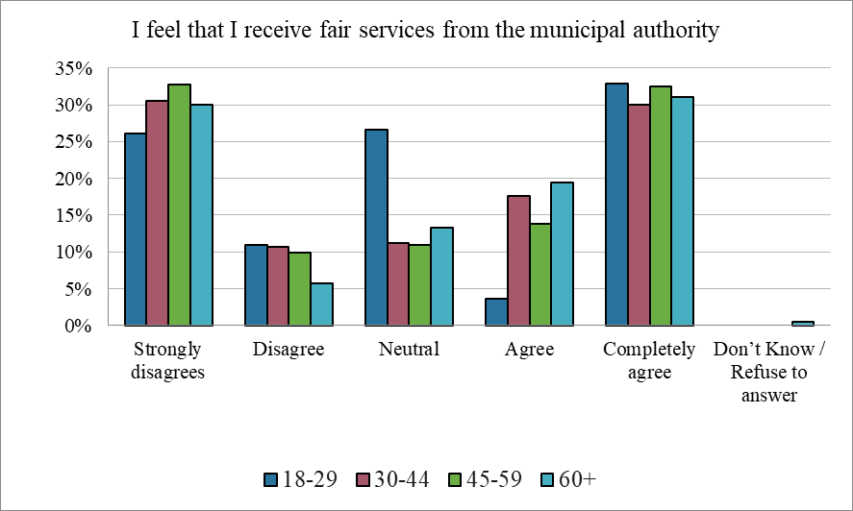
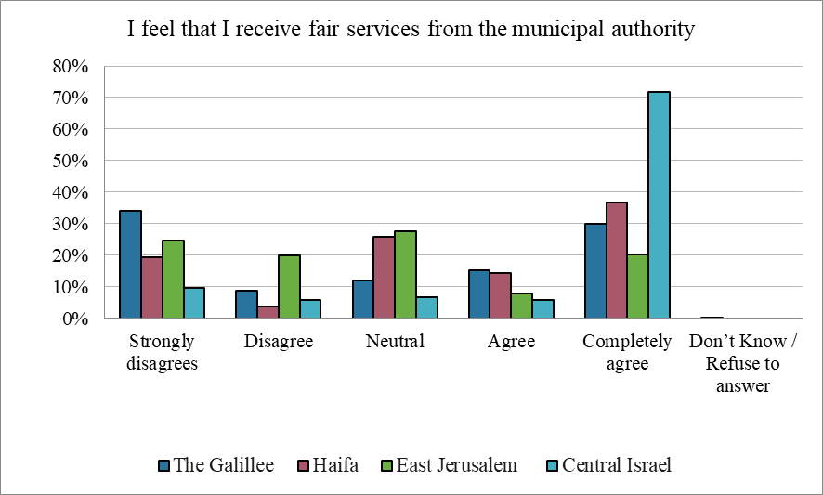

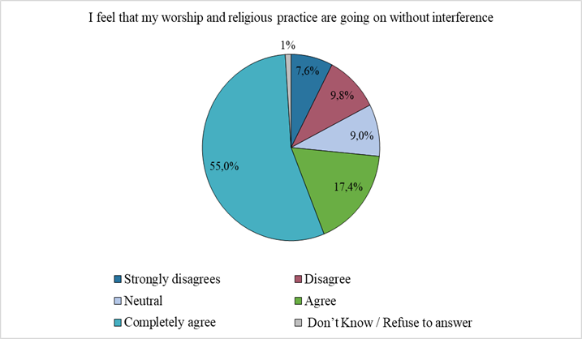

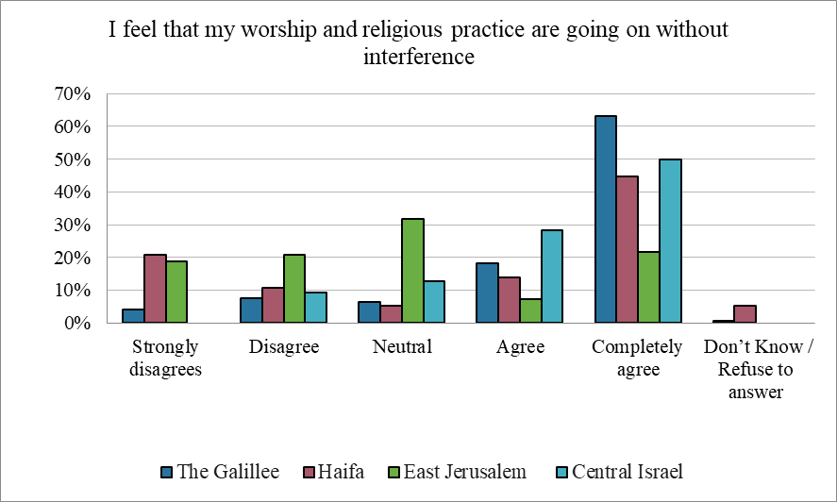

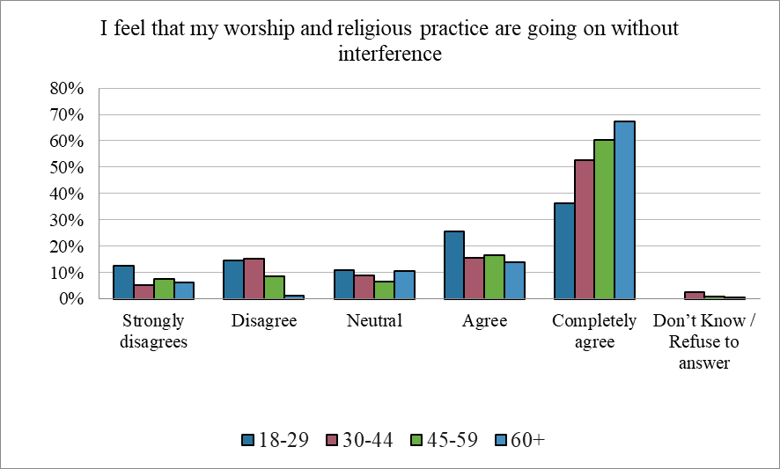

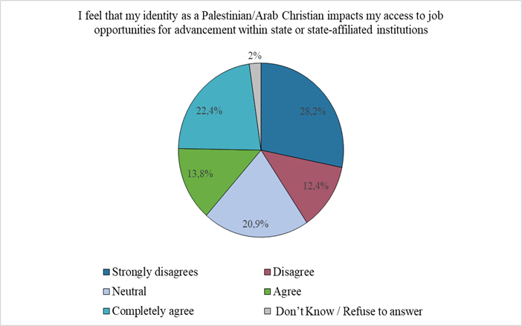

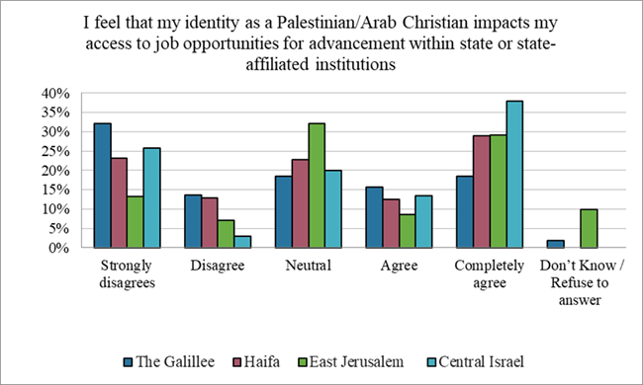

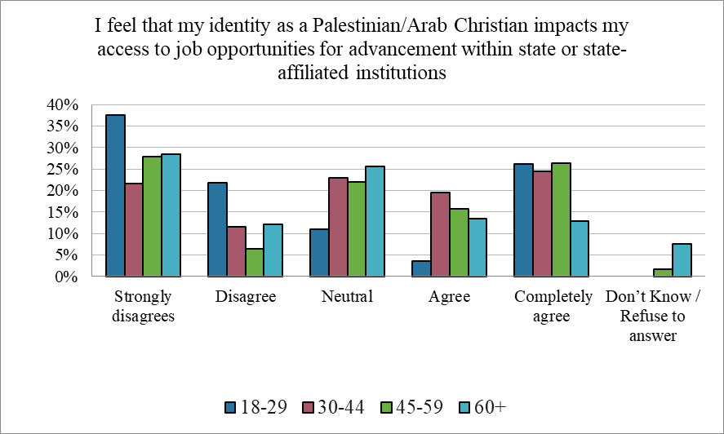

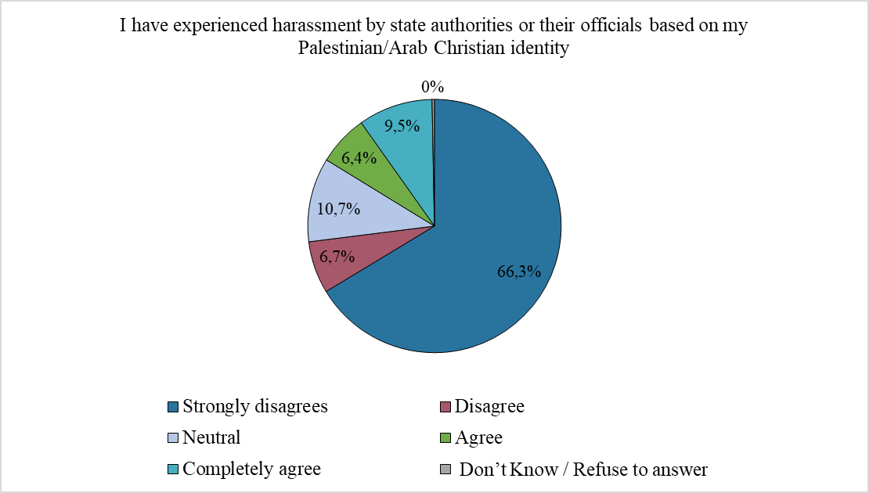

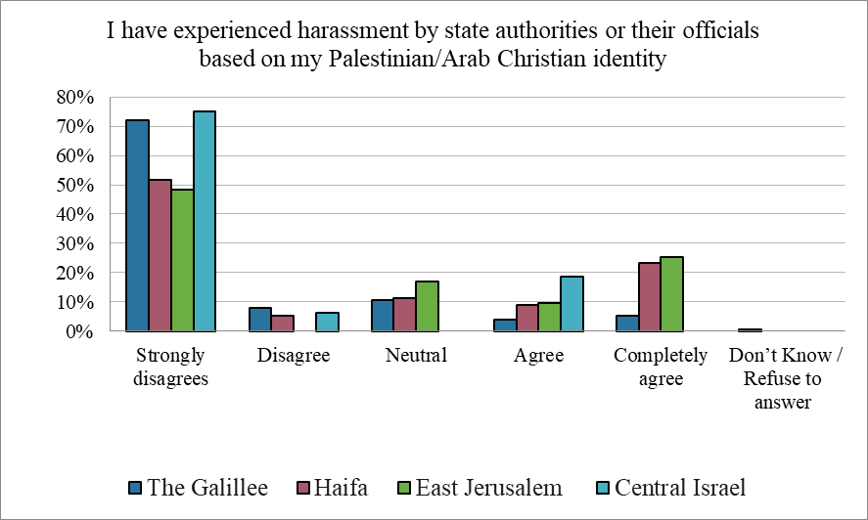

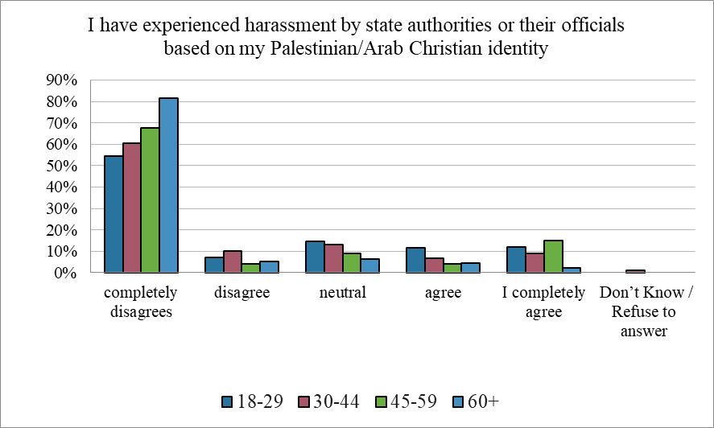

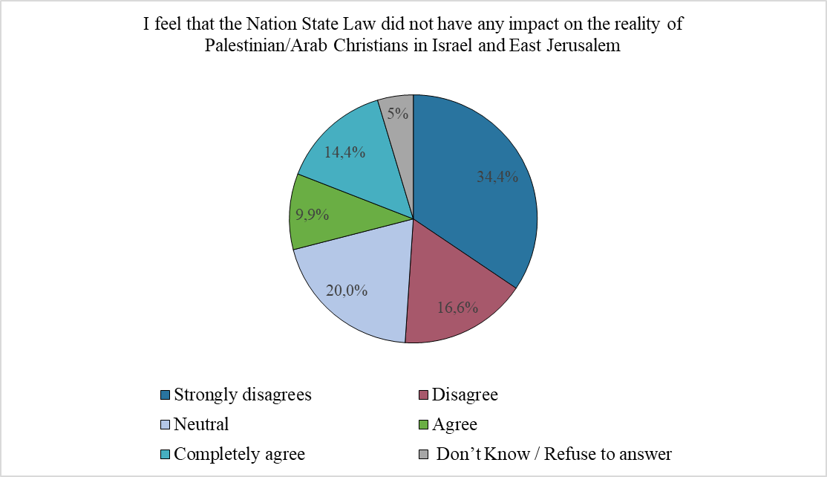

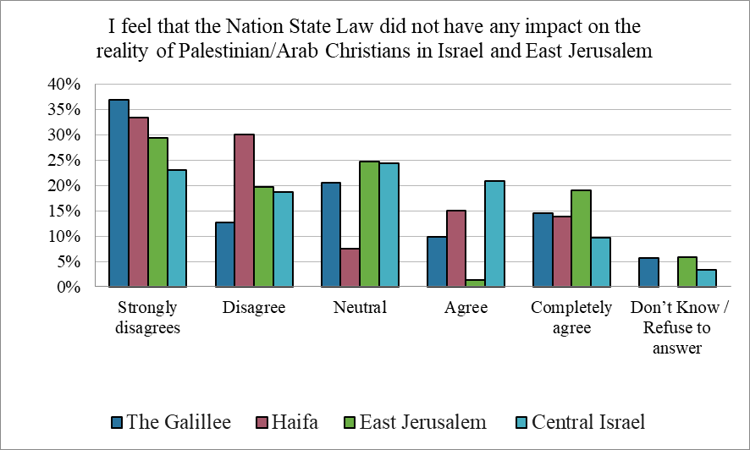

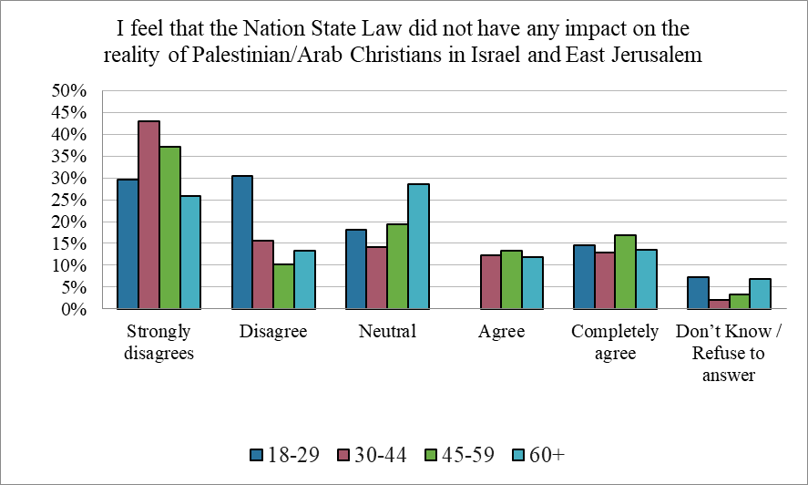

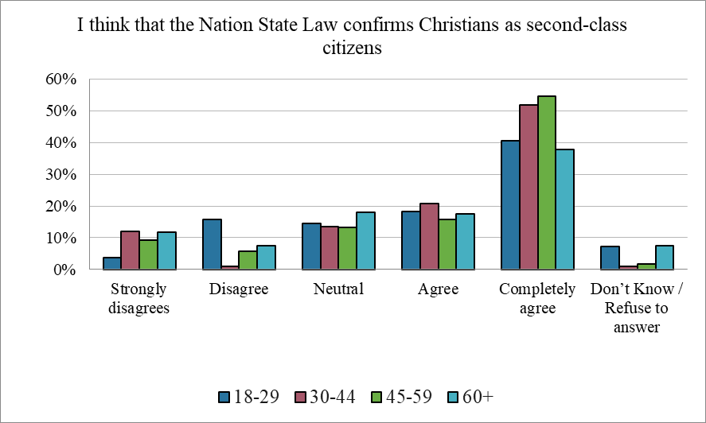
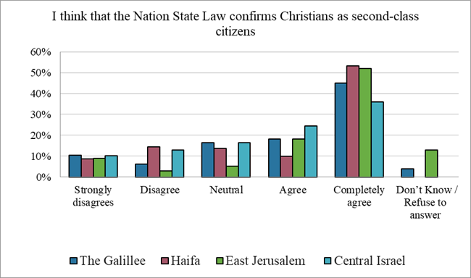
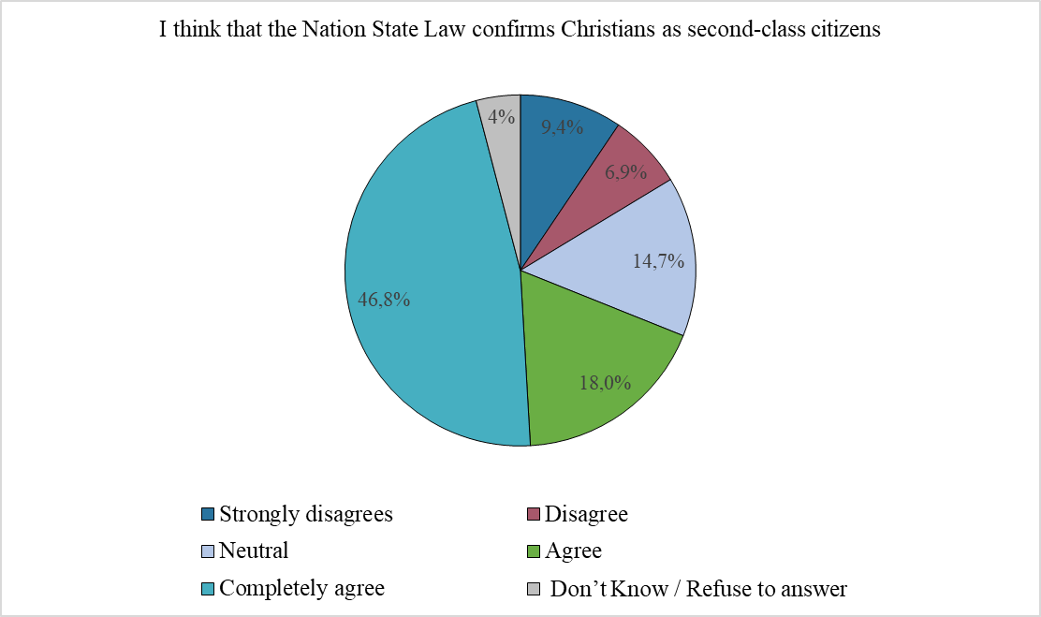

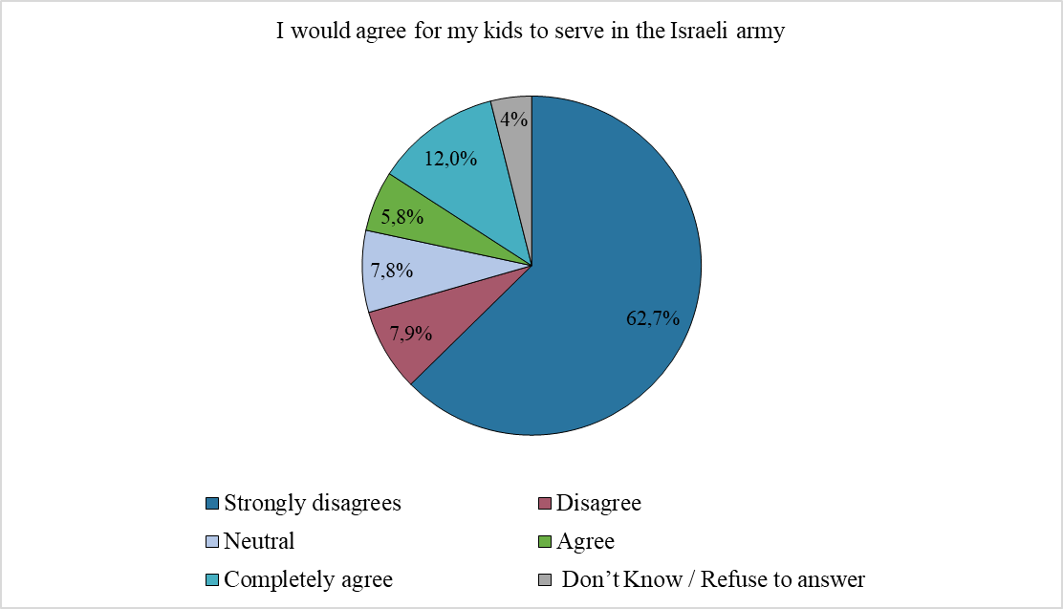

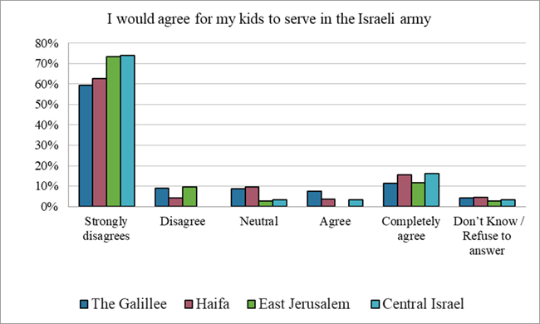

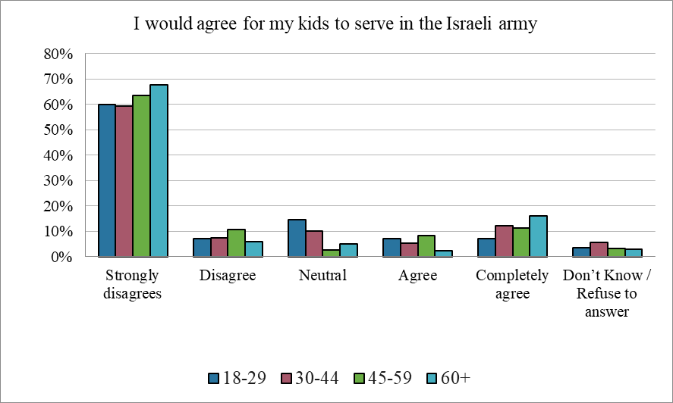

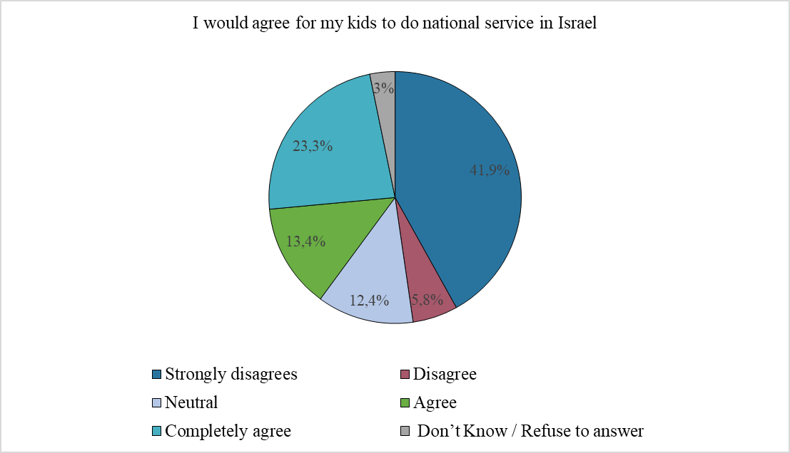

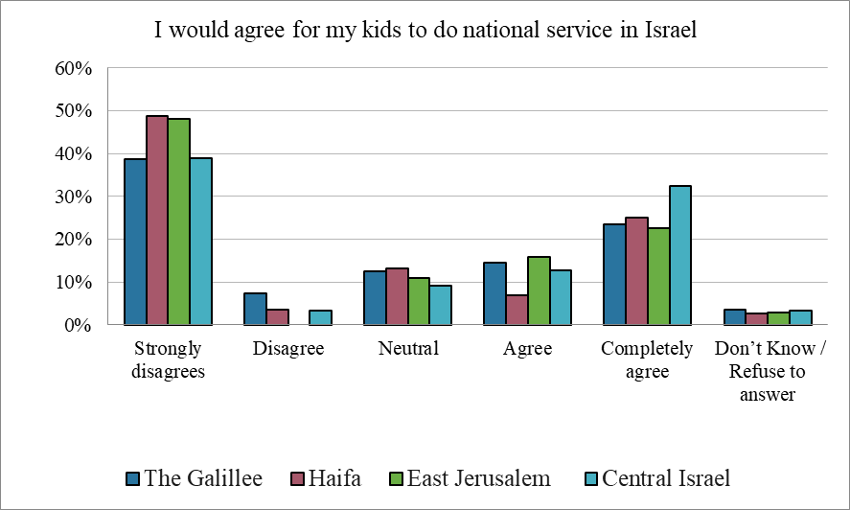
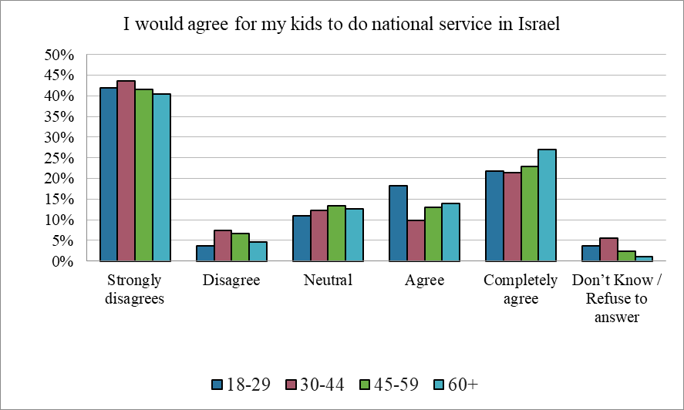
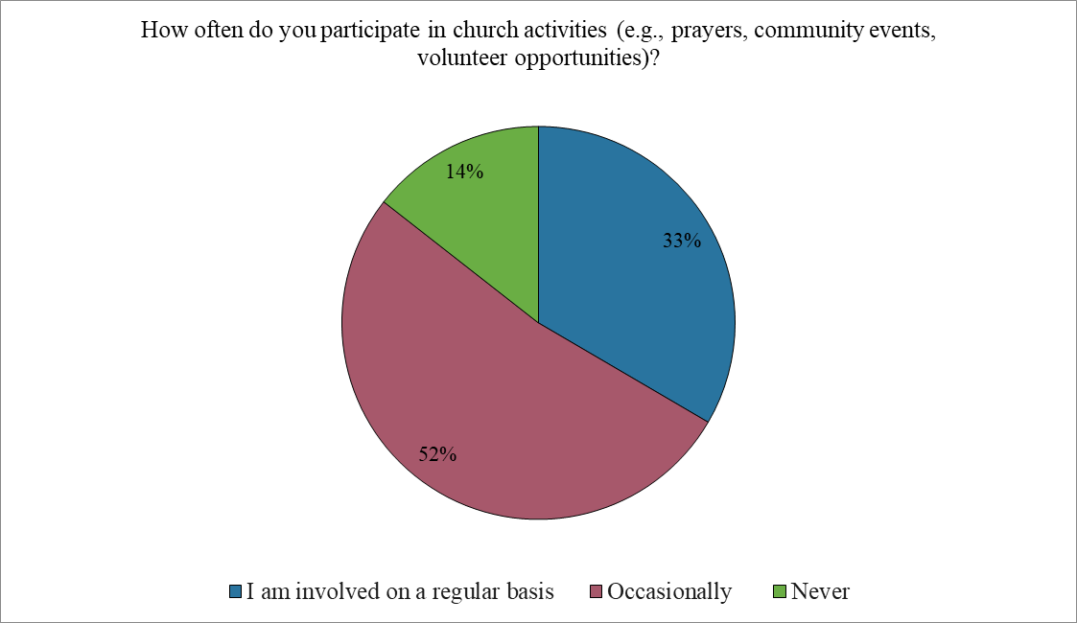

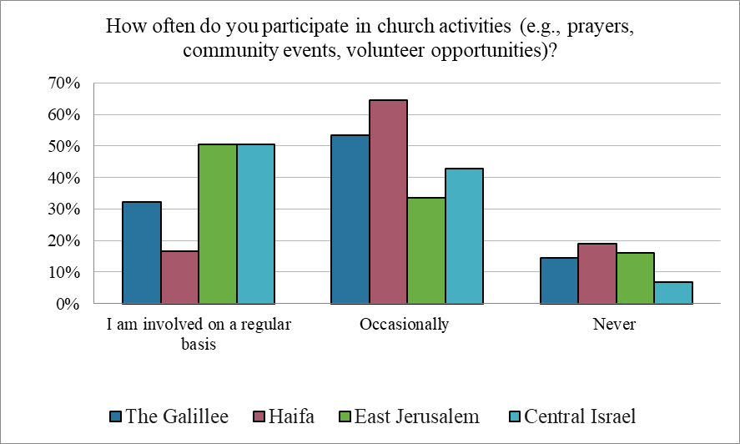

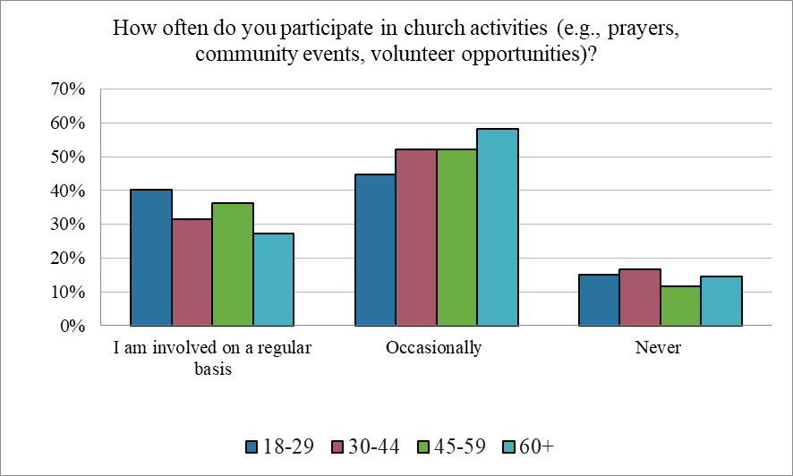

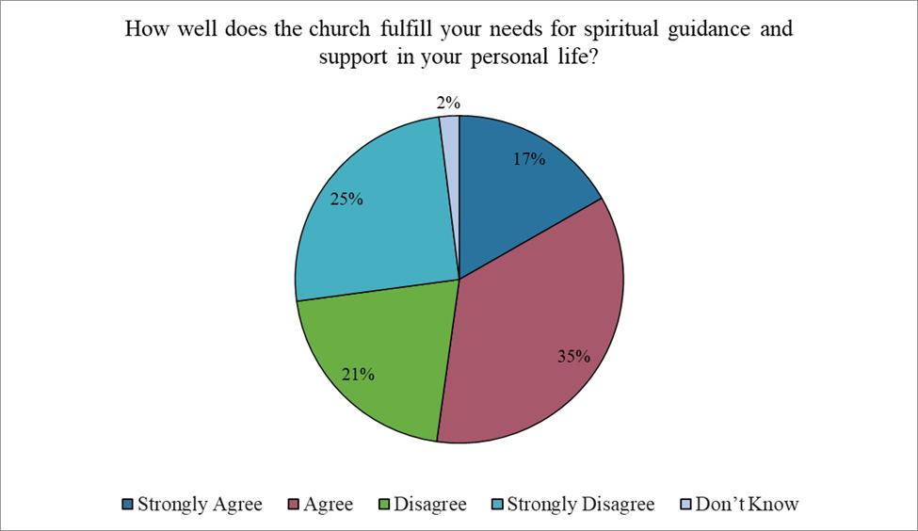

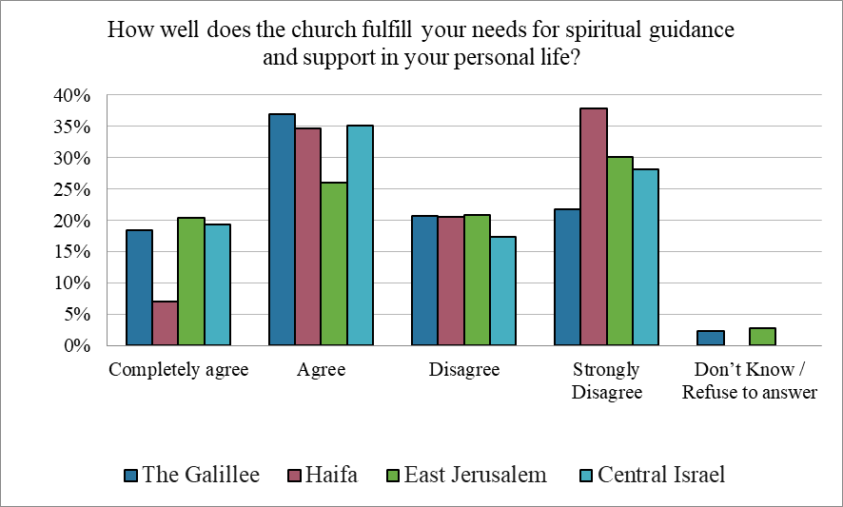

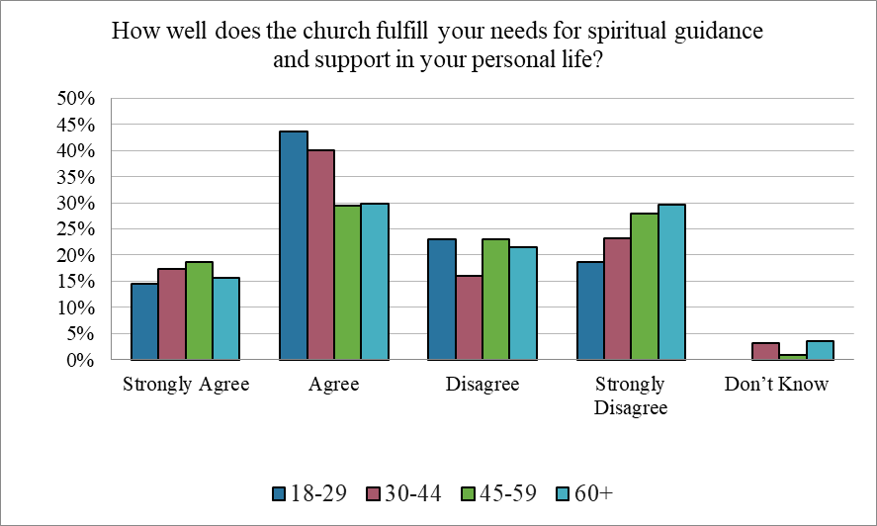

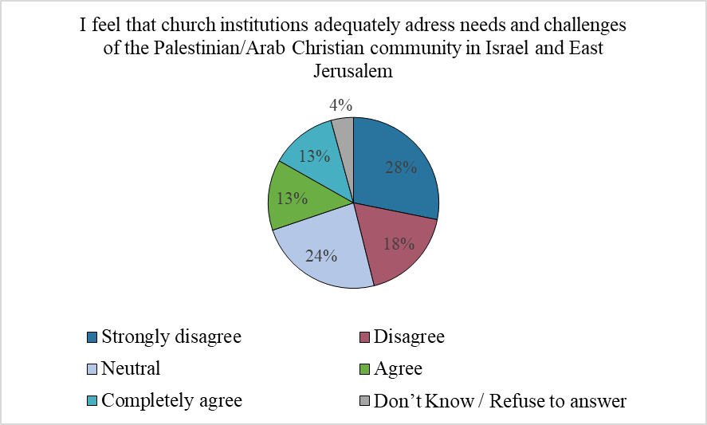

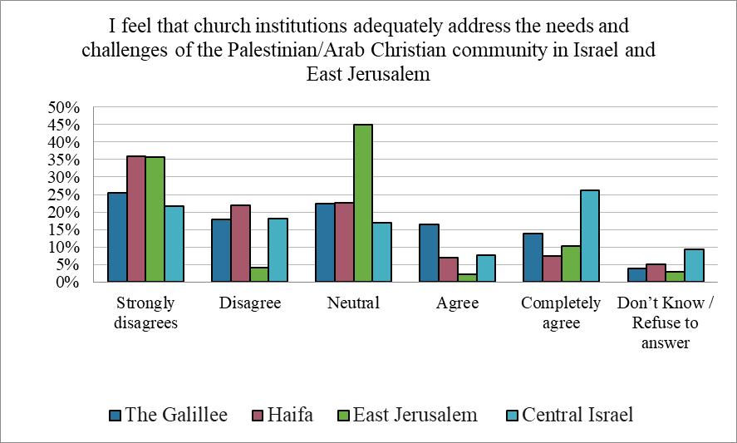

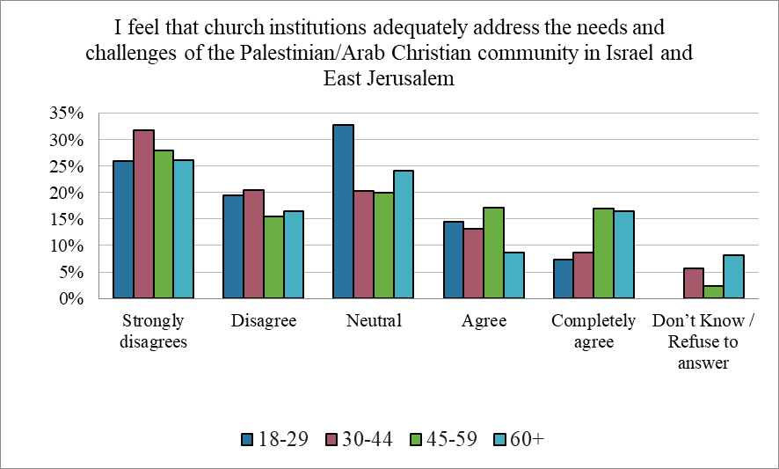

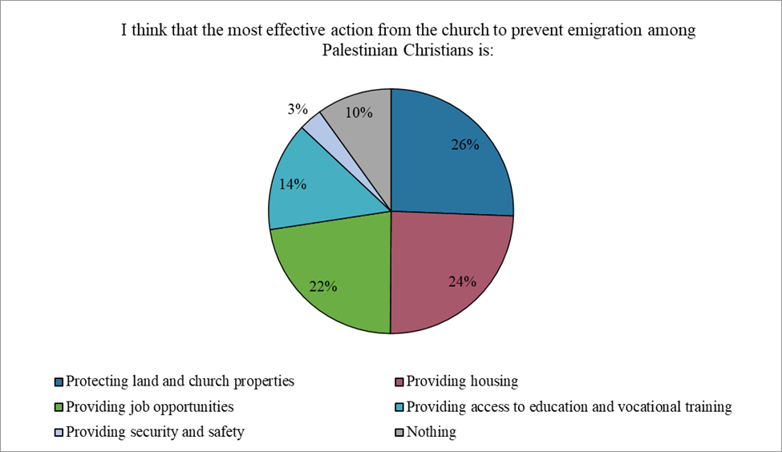

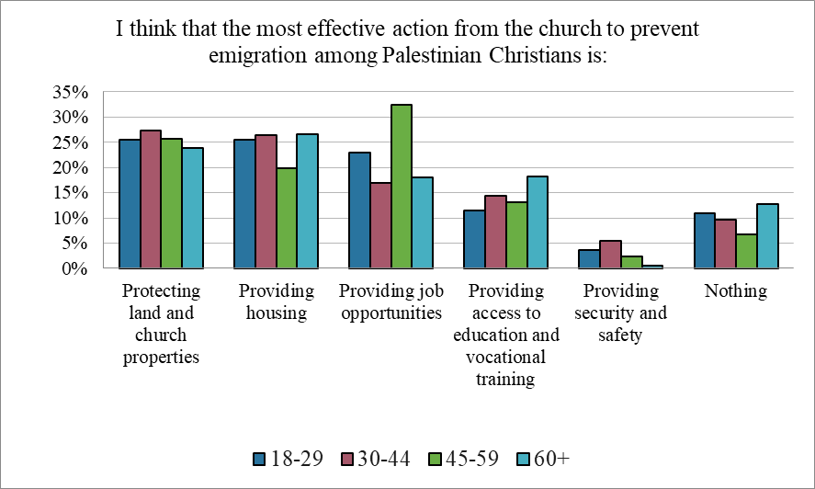
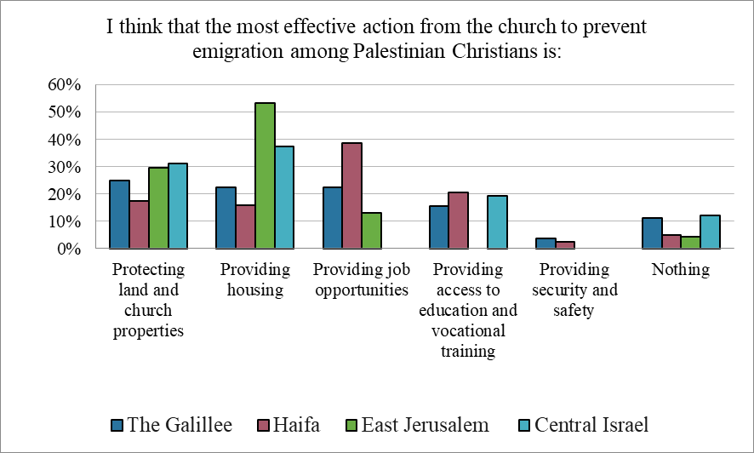

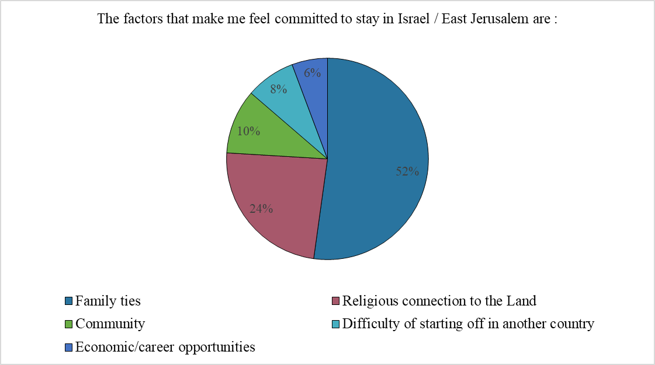

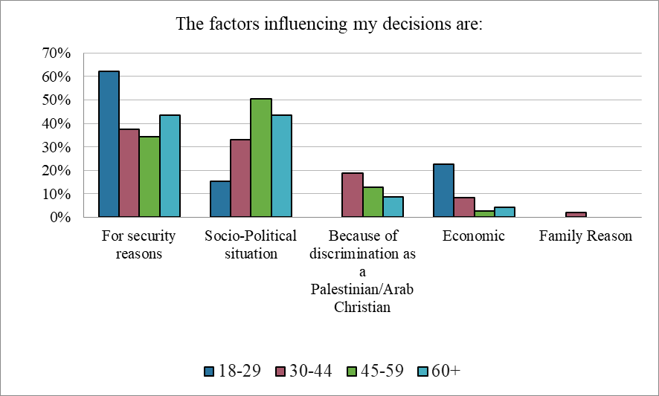
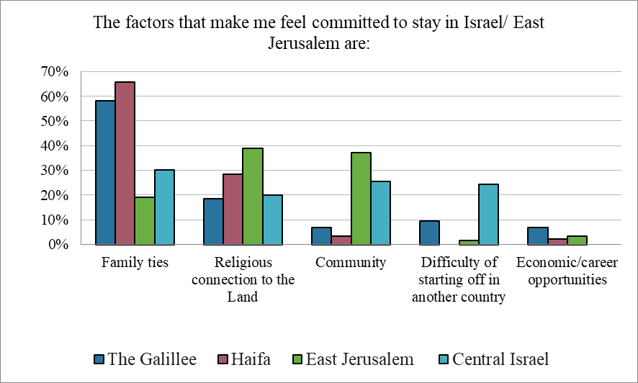

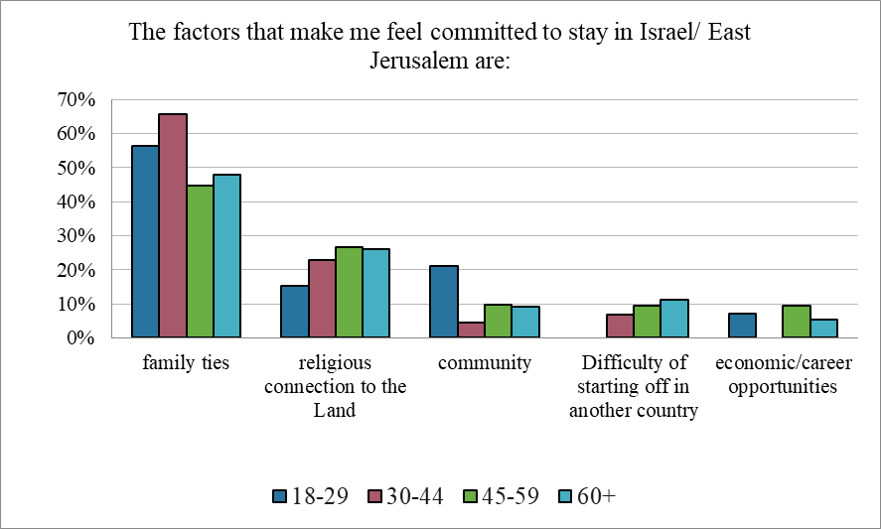

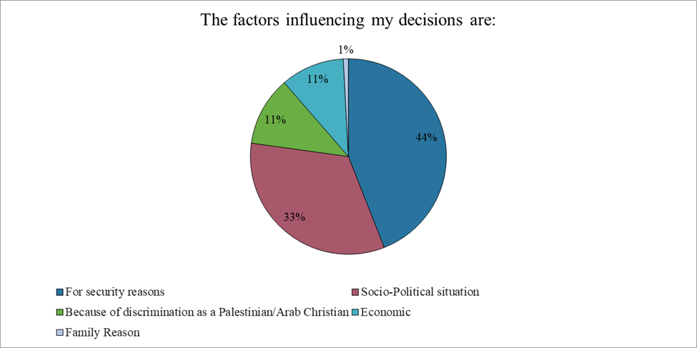

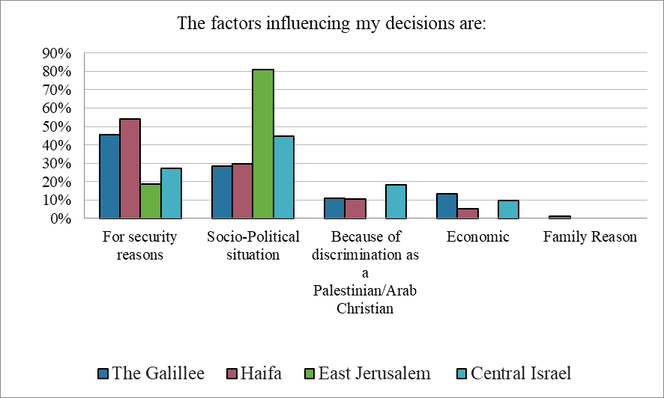

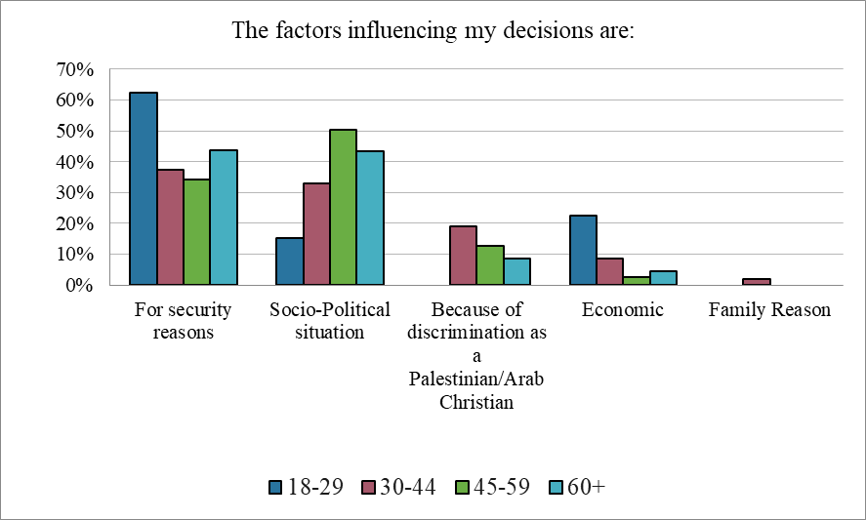

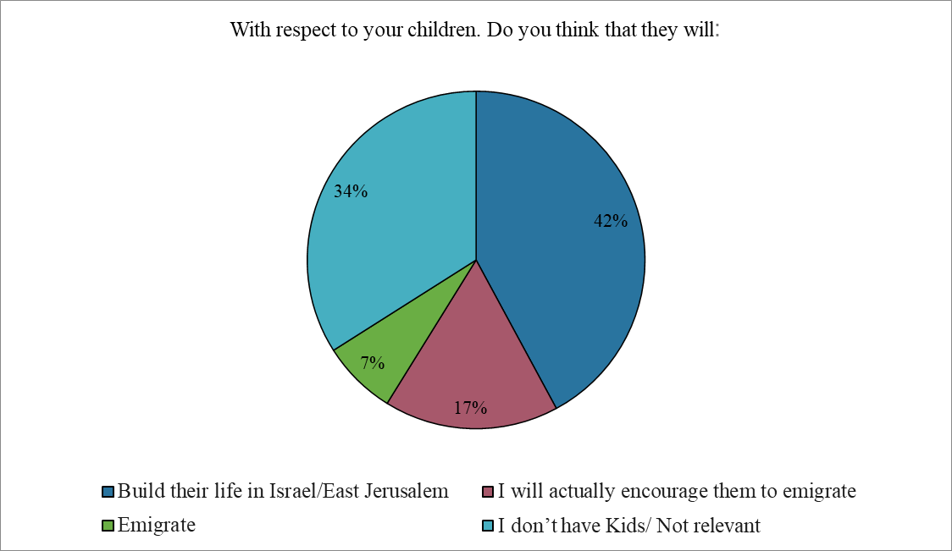

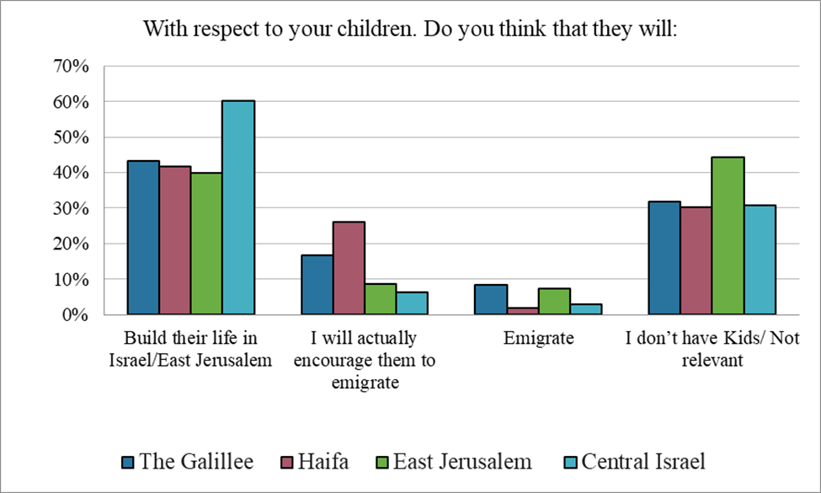

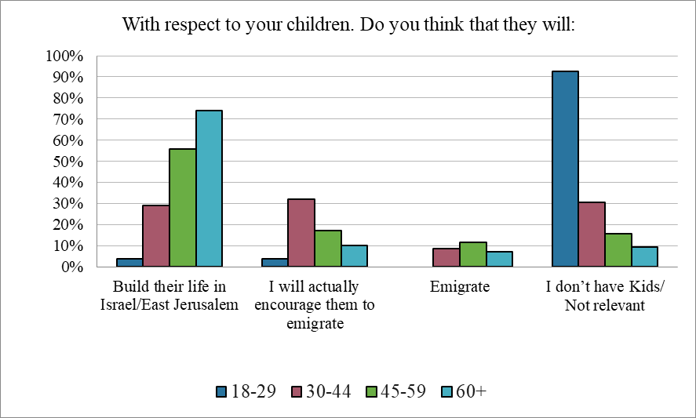

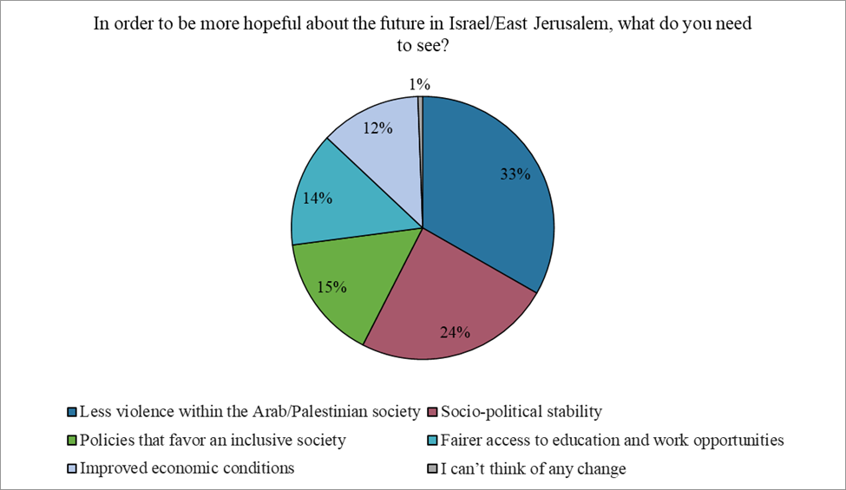

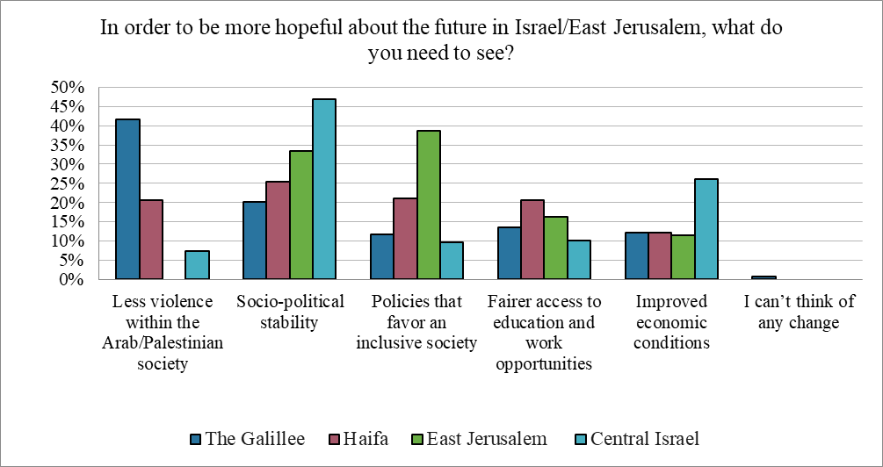
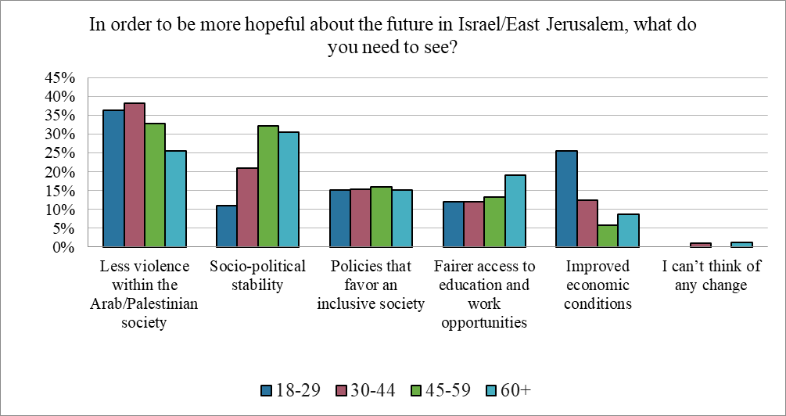

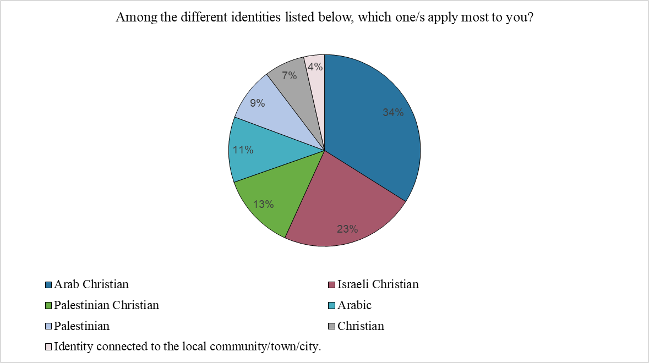

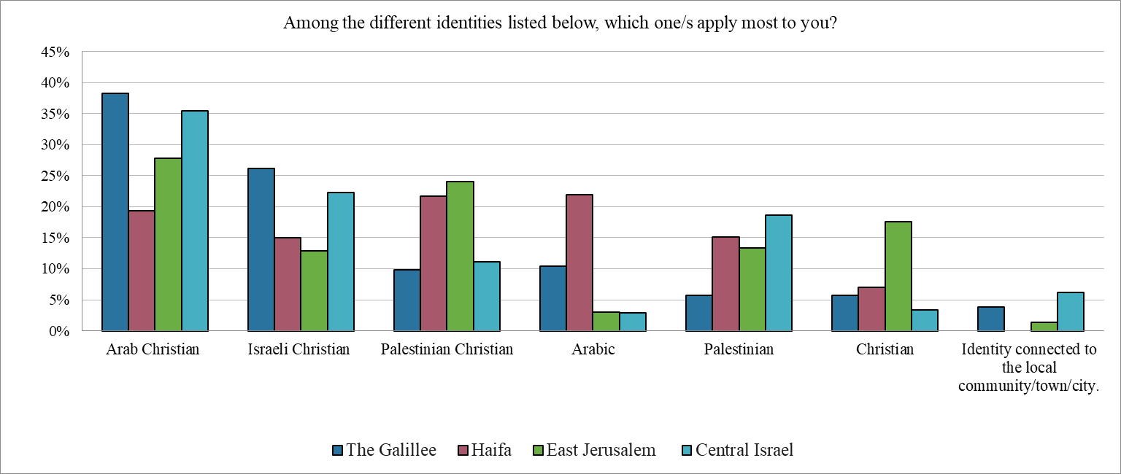

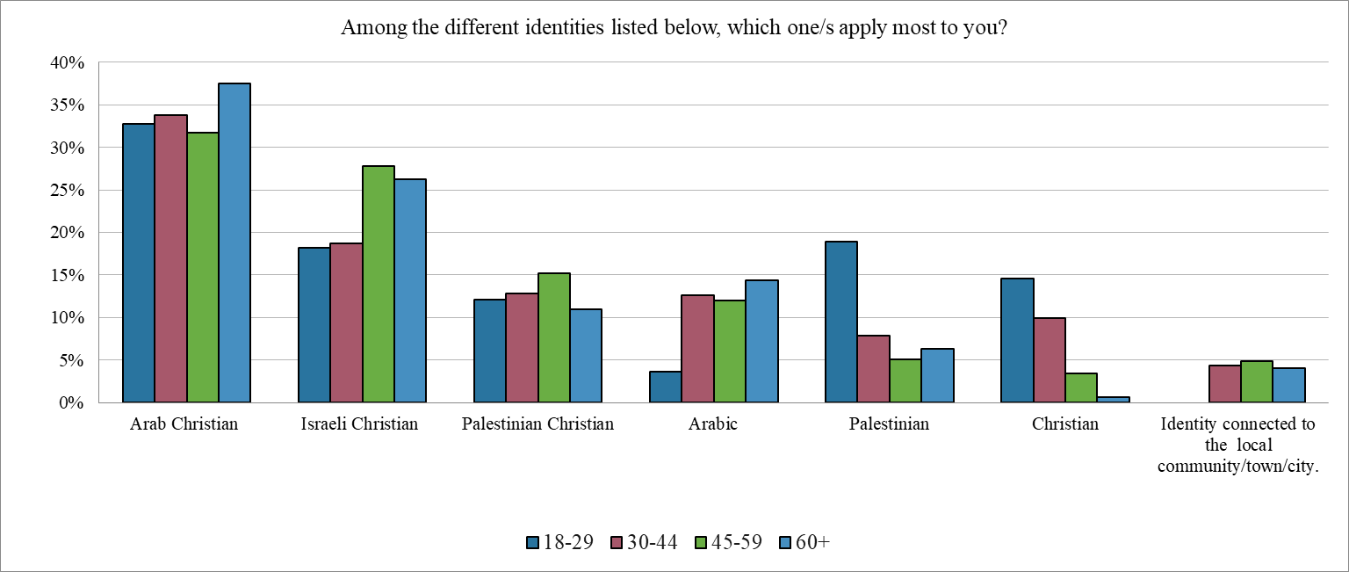

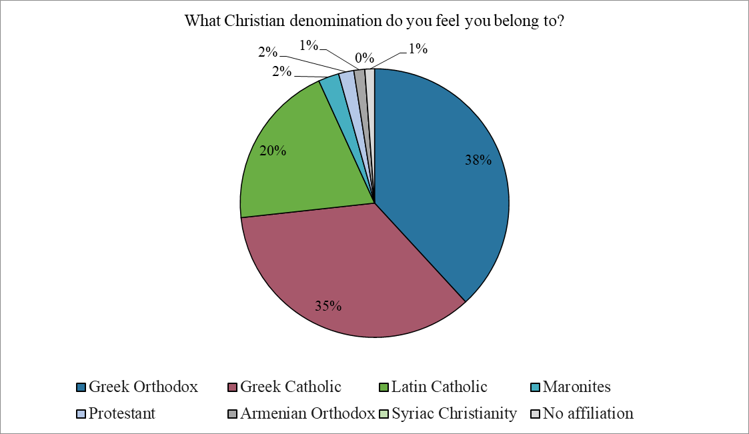







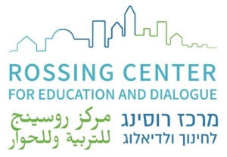

info@rossingcenter.org Donate Tel: +972-2-676-4103
Survey among Local Christians in Israel & East Jerusalem – 2025 41

